Refreshable Braille Displays
Refreshable Braille Displays allow people who are deaf or blind to use mobile phones, tablets, computers and other smart devices.
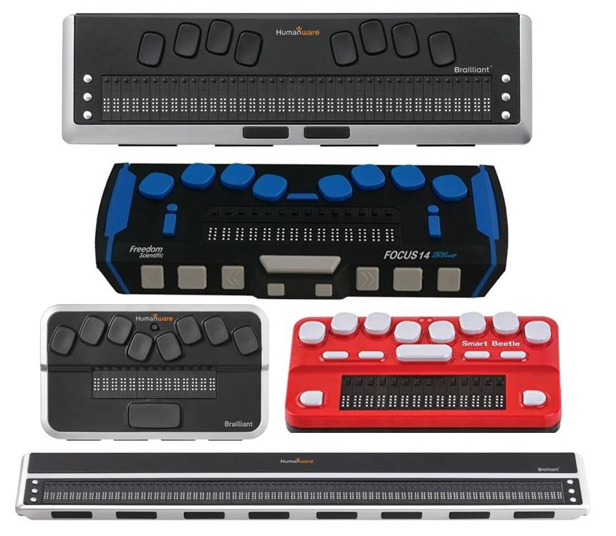
Type of accessory: Braille Displays

How do you use these accessories?
Pair these accessories to your mobile phone or tablet via Bluetooth. The refreshable braille display will show the text of each app as you browse them and you will be able to enter text on text fields using the 8-key braille keyboard.
Use this accessory to access the SMS or internet functions of your phone to contact the National Relay Service for assistance to complete a phone call.
Video showing the use of a Refreshable Braille Display with an Apple tablet

These accessories connect to phones via:
Audio Jack: No
Bluetooth: Yes
Wi-Fi: No
Micro USB: No
Other: No

Is there any other piece of equipment required for this accessory to work properly with a phone?
No, these accessories do not require any additional equipment to connect or work properly with a smart phone or tablet.
Apple devices have a built-in braille access when using the VoiceOver Screen Reader. However for Android devices, you must download the Google BrailleBack App to support the use of Bluetooth braille displays.

Compatibility:
Most Refreshable Braille Displays are compatible with Android, Apple and Microsoft devices. Each Braille Display will be compatible with a different operating system.

Popular Refreshable Braille Displays available in Australia:

HumanWare Brailliant BI 40 Braille Display

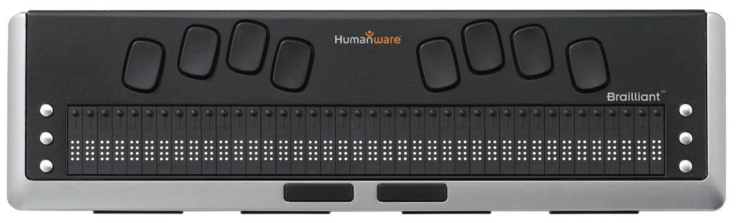

Features:
- 40 Braille cells
- Designed for extensive reading
- Eight-key braille keyboard
- Six command keys
- Four thumb keys
- Two spacebars
- Curser router keys
- USB 2.0. and Bluetooth V2.1
- Lasts up to 20 hours with Bluetooth
- Automatic shut-off
Compatibility: Windows 10, Android 4.4+, all iOS, and Mac OSX10.8 or later.
Available at: Vision Australia and Humanware. You can also find a Humanware distributor near you.
More information on:
HumanWare Brailliant BI 40 Web Page
HumanWare Brailliant Support Web Page

HumanWare Brailliant BI 80 Braille Display
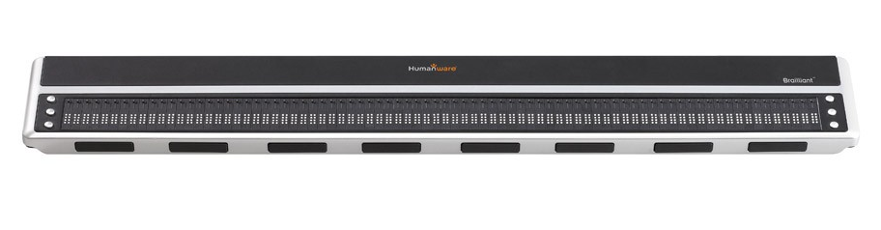
Features:
- 80 Braille cells
- Designed for extensive reading
- Eight-key braille keyboard
- Six command keys
- Four thumb keys
- Two spacebars
- Curser router keys
- USB 2.0. and Bluetooth V2.1
- Lasts up to 20 hours with Bluetooth
- Automatic shut-off
Compatibility: Windows 10, Android 4.4+, all iOS, and Mac OSX10.8 or later.
Available at: Humanware. You can also find a Humanware distributor near you.
More information on:
HumanWare Brailliant BI 80 Web Page
HumanWare Brailliant Support Web Page

HumanWare Brailliant Display 14 Cells with input (BI14)

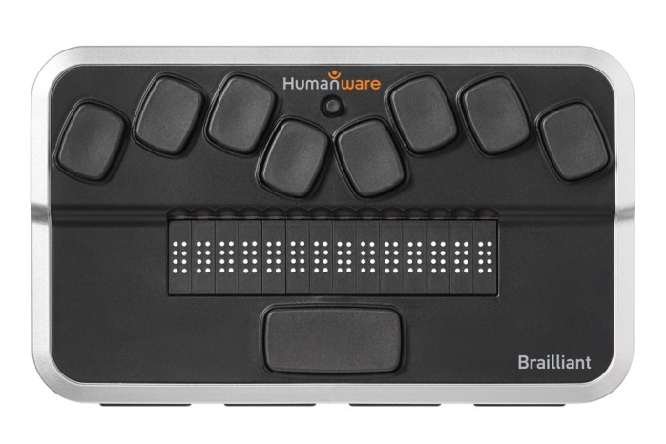
Features:
- 14 Braille cells
- Rugged design built for the user on the go
- Very light: 285 G 0.63 lbs.
- Ergonomic traditional 8-dot braille input keys
- Comfortable typing experience with a note taker style spacebar
- HumanWare signature thumb keys
- Built-in intelligence allows for increased productivity anywhere
- Pair up to 5 Bluetooth devices at once Plus one USB connection
- Brailliant Sync ensures notes taken on the BI14 are available everywhere!
Compatibility: Windows 10, Android 4.4+, all iOS, and Mac OSX10.8 or later.
Available at: Vision Australia and Humanware. You can also find a Humanware distributor near you.
More information on:
HumanWare Brailliant BI 40 Web Page
HumanWare Brailliant Support Web Page

Focus 14 5th Gen Blue Braille Display
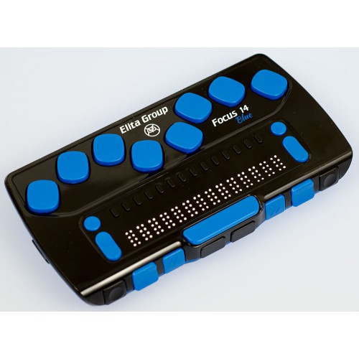
Features:
- 14 Braille cells
- 8-dot Braille keyboard
- Seamless Braille with a more crisp and uniform feel
- Compact and durable - designed for portability
- Convenient front panel controls and customizable NAV rockers
- Our exclusive NAV Rockers let you rapidly scroll by line, sentence, paragraph, or pan through a document
- Menu button, conveniently centred above the cursor router buttons, for quick access to calendar, clock, Bluetooth connections, and more
- Built-in Scratchpad with BRF Book Reader
- Select your personal Braille firmness with VariBraille
- USB-C micro connector - always right-side-up to reduce wear and tear
- Charge battery via USB
- Unique use-in carrying case
- Weight: Approximately 283 grams (10 oz.)
Compatibility: Is compatible with iOS 11 or later and Android devices with Google BrailleBack
Available at: Quantum
More information on:
Focus 14 Wireless Braille Display Brochure (Download)

Focus 14 Blue Generation 5 Braille Display
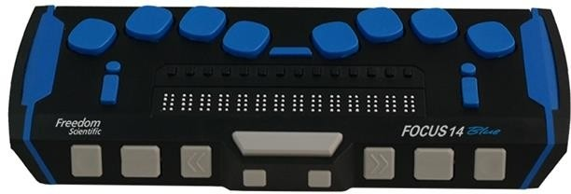
Features:
- 14 Braille cells
- 8-dot Braille keyboard
- Smooth, paper-like feel
- Convenient thumb key and panning buttons
- Our exclusive NAV Rockers let you rapidly scroll by line, sentence, paragraph, or pan through a document
- Menu button for quick access to settings
- Adjustable key repeat for rapid scrolling and panning
- Select your personal Braille firmness with VariBraille
- Time and Date display
- Out-of-the box compatibility with Apple® iOS 11 or later and Android devices
Compatibility: Is compatible with iOS 11 or later and Android devices with Google BrailleBack
Available at: Quantum and Vision Australia.
More information on:
Focus 14 Freedom Scientific Web Page
Focus 14 Blue - 5th Generation Braille Display Website

Focus 40 Blue Generation 5 Braille Display
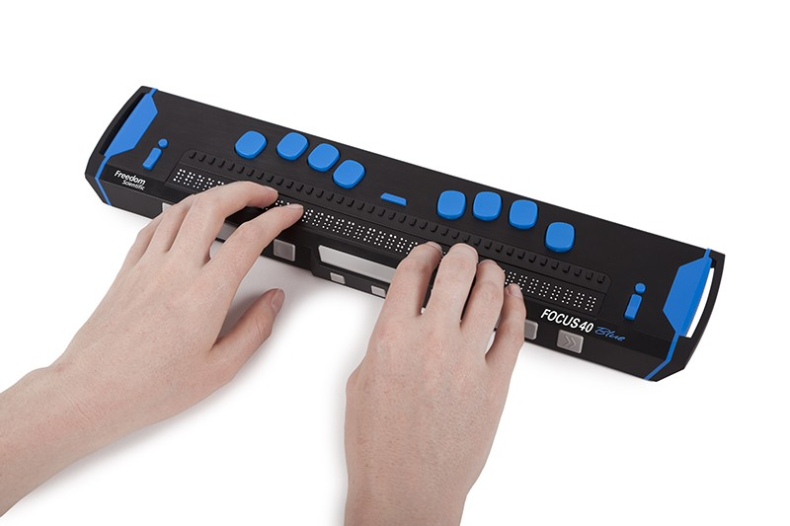
Features:
- 40 Braille cells
- 8-dot Braille keyboard
- Smooth, paper-like feel
- Convenient thumb key and panning buttons
- Our exclusive NAV Rockers let you rapidly scroll by line, sentence, paragraph, or pan through a document
- Menu button for quick access to settings
- Adjustable key repeat for rapid scrolling and panning
- Select your personal Braille firmness with VariBraille
- Time and date display
Compatibility: Is compatible with iOS 11 or later and Android devices with Google BrailleBack
Available at: Quantum.
More information on:
Focus 40 Freedom Scientific Web Page
Focus 40 Blue - 5th Generation Braille Display Website

Smart Beetle Braille Display
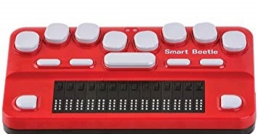

Features:
- Allows full access to phone via Braille Output on the display and input via braille keyboard.
- Braille can be customized to Grade 1 or Grade 2.
- Can Pair with 5 Bluetooth Devices.
Available at: Pacific Vision and Vision Australia.
More information on:
HIMS Smart Beetle Web Page
Smart Beetle Resources

Is there any training available for these accessories?
Training and demonstrations might be available directly from retailers.
Please contact HumanWare Australia, Quantum and Vision Australia for demonstrations and training on their products. Ablelink can also provide training on learning how to use Braille devices.

Connecting to Braille Displays on iOS and Android

Voice Control – Apple
Voice Control on Apple comes built-in to the latest Apple iPhone and iPad devices, allowing you to fully control you device using your voice. It also has a braille access feature enabled when using the screen reader. Utilizing this braille access allows a user to receive braille output on a supported braille display, and if the display has input keys, one can actually control the iOS device without ever touching the device's touch screen.
Compatibility: Available for iOS 3.0 and up. Some devices will have Voice Control built in to Siri, the iOS personal assistant, however for information on changing Voice Control for earlier versions please see the Apple Support Page.
More information at:
Apple Voice Control Support Web Page
How to navigate with Voice Control on iPhone or iPad Video (YouTube)

Google BrailleBack
The Google BrailleBack App is required for android devices to support braille devices.
This app lets you connect a supported refreshable braille display to your device via Bluetooth. Screen content will be presented on the braille display and you can navigate and interact with your device using the keys on the display. It works together with the TalkBack app to give a combined braille and speech experience, allowing you to input text using your braille keyboard.
Once installed, you must activate your braille device for the app to work. Steps to activate include: Go to Settings > Accessibility > turn on BrailleBack switch and then go back to Settings > Bluetooth > pair your Bluetooth braille display.
Instructions on installing and turning on BrailleBack on your device and a list of compatible braille devices can be found at BrailleBack Android Support Web Page or Freedom Scientific Braille and Android Info Web Page
Compatibility: Requires Android 4.1 and up
Price: Free.
You can download this app from the Google Play Store.

