TTY, RTT, and CapTel
TTY, RTT, and CapTel refer to alternative communication systems that are designed for people who are deaf, hearing impaired, or speech impaired. These systems allow the use of written messages while being on a phone call.

TTY and Text Telephones
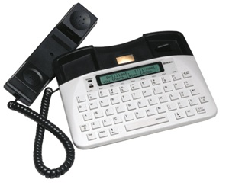
A TTY or Teletypewriter is a telephone-like device that incorporates a screen and a keyboard that allows you to send and receive written messages over the telephone network. This service is used by people who are deaf, hearing impaired, or speech impaired.
These can only be used over a landline connection, or the telephone socket on your NBN supported modem.
The National Relay Service provides the required support for this type of calls.
A person with speech impairment might prefer to type a message for the relay officer to pass to the person on the other side of the line, while a Deaf person might benefit from reading the messages that the relay officer types on behalf of the other person on the line.
TTY devices can usually be rented through the Disability Equipment Programs offered by Telstra or Optus.
Uniphone 1150 TTY may be purchased outright from ClearaSound.

CapTel Telephone
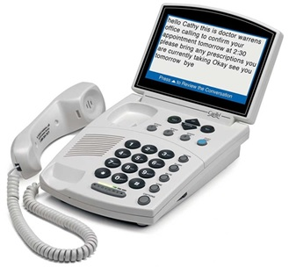
A CapTel Telephone is a captioned telephone that allows users to make phone calls with the added feature of having the incoming speech both heard by the user, as well as captioned for the user to read and respond to. It is designed to work with the captioning service of the National Relay Service, which had an officer ready to transcribe incoming spoken words into written captions, allowing individuals who are deaf and hearing impaired to communicate more effectively.
CapTel handsets are no longer available in Australia, as this service will be shut down in February 2020 and users will be required to switch to a teletypewriter (TTY) or an alternative service in order to receive captioned phone calls.

Real-Time-Text
Real-Time-Text allows individuals to have a real-time conversation over text as an alternative to a phone call. In call with real-time text, each character is transmitted immediately as it is typed, and there is no delay between sending and receiving messages. You can also talk and text simultaneously over the same connection. RTT can feel like a more natural form of communication than TTY or text messaging.
RTT requires connection to a mobile network that enables this function. This service is currently not available in the Australia.

More Information:
ACCAN Disability Equipment Rights Web Page
Accesshub National Relay Service Web Page
Telstra Disability Equipment Program Web Page
Optus Disability Services Web Page

Training and demonstrations of TTY equipment may be available at Independent Living Centre Australia, Telstra, Optus or ClearaSound. Please contact any of them for further information.

