iPad Keyguards
A tablet keyguard is a plate that sits on top of the tablet. It contains a number of separate holes that simulate the layout of the tablet’s virtual keyboard. The purpose of these holes is to guide the user’s finger to the correct key. Keyguards are useful for people who have difficulties with fine motor control.
Type of accessory: Tablet Keyguard
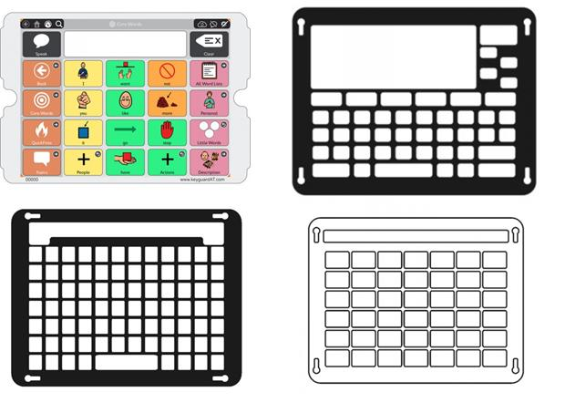

How do you use these accessories?
Open the keyboard on your iPad, place the keyguard on top of your iPad and proceed to type.
Video of person using a tablet keyguard by Invotek Inc.

Compatibility:
Tablet Keyguards are designed to fit a specific tablet models and their operating systems or APP keyboards. Check with the supplier before purchase to make sure the key guard is suitable for your tablet model and keyboard layout.

IPad Keyguards available in Australia:

Onscreen Keyboard Keyguard for iPad
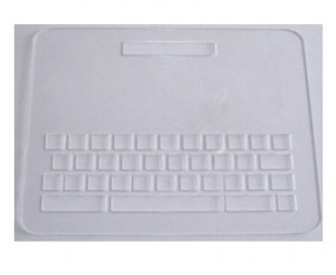
Description:
Use this keyguard with the built in iPad keyboard in the QWERTY/QWERTZ or AZERTY configuration. Keyguard may be ordered either full size or half size (for apps requiring access to the screen for swiping etc.)
More information at Onscreen Keyboard Keyguard for iPad at Communicate AT
You can buy this accessory from Communicate AT

Co:Writer Keyguard for iPad
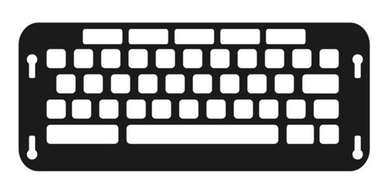
Description:
This keyguard has been designed to fit the Co:Writer app from Don Johnston Inc. The keyguard cells fit the onscreen keyboard layout and word prediction list of Co:Writer (all language versions).
This keyguard is cut and supplied in clear acrylic; the images shown are black to highlight the layout of the guard and are for illustrative purposes only.
More information at Co:Writer Keyguard for IPad at Communicate AT
You can buy this accessory from Communicate AT

Compass PODD Keyguard for iPad
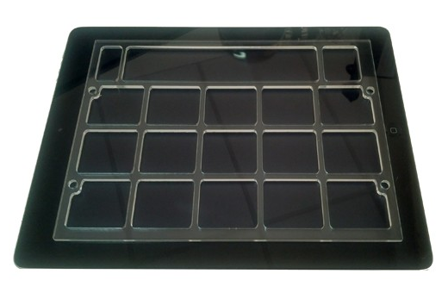
Description:
This keyguard fits the layout of the Compass PODD 15 cell Augmentative and Alternative Communication App for iPad. This guard is in landscape orientation only and is made to fit the most common cases being used with the iPad (there are exceptions involved). Choose and select from the options to create your PODD 15 keyguard.
More information at: Compass PODD Keyguard for IPad at Communicate AT
You can buy this accessory from Communicate AT

GoTalk Now Keyguard for iPad
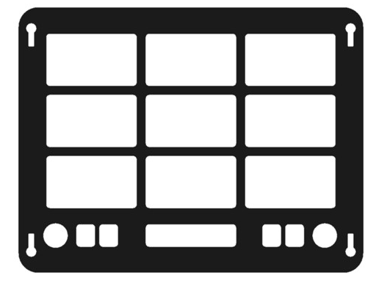
Description:
This keyguard fits the layout of the GoTalk Now Augmentative and Alternative Communication App for iPad. Available in one, two, four, nine, sixteen or twenty five cell arrangement as per the setup of the App. One guard per setup.
More information at: GoTalk Now Keyguard for IPad at Communicate AT
You can buy this accessory from Communicate AT

LAMP Words for Life Keyguard for iPad
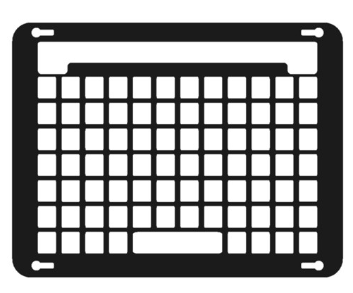
Description:
This keyguard fits the layout of the LAMP Words for Life Augmentative and Alternative Communication App for iPad. Landscape orientation only with choices how your keyguard is attached to your iPad or your iPad case.
More information at: LAMP Words for Life Keyguard for IPad at Communicate AT
You can buy this accessory from Communicate AT

Predictable V3 Keyguard for iPad
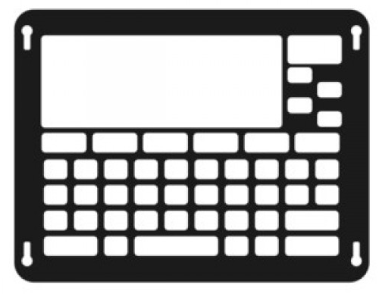
Description:
This keyguard matches the keyboard in the iPad Predictable Augmentative and Alternative Communication App, version 3 or greater.
More information at: Predictable V3 Keyguard for IPad at Communicate AT
You can buy this accessory from Communicate AT

Proloquo2Go Keyguard for iPad
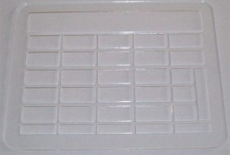
Description:
This keyguard fits the layout of the Proloquo2Go (version 2 or higher) Augmentative and Alternative Communication App for iPad. All the page setup options available make this the most complex keyguard to produce, thus all our setup questions if ordering.
More information at: Proloquo2Go Keyguard for IPad at Communicate AT
You can buy this accessory from Communicate AT

Snap + Core First Keyguard for iPad
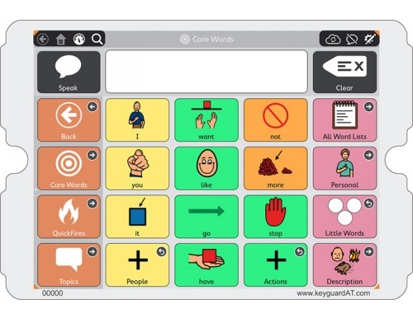
Description:
This keyguard fits the layout of the Snap + Core First App for iPad from Tobbi-Dynavox. Landscape orientation only with choices how your keyguard is attached to your iPad or your iPad case.
More information at: Snap + Core First Keyguard for IPad at Communicate AT
You can buy this accessory from Communicate AT

Sono Flex Keyguard for iPad
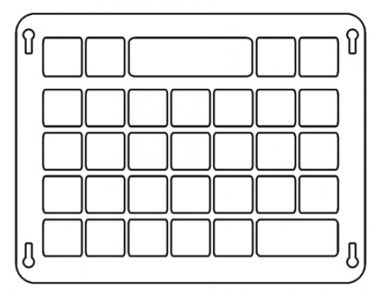
Description:
This Keyguard fits the layout of the Sono Flex Augmentative and Alternative Communication App for iPad.
More information at: Sono Flex Keyguard for IPad at Communicate AT
You can buy this accessory from Communicate AT

Touch Chat Keyguard for iPad
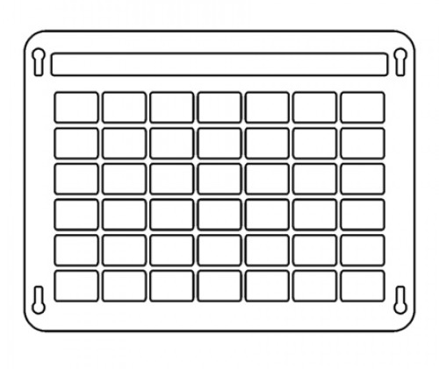
Description:
This keyguard fits the layout of the Touch Chat Augmentative and Alternative Communication App installed on your iPad.
More information at: Touch Chat Keyguard for IPad at Communicate AT
You can buy this accessory from Communicate AT

Verbally Keyguard for iPad
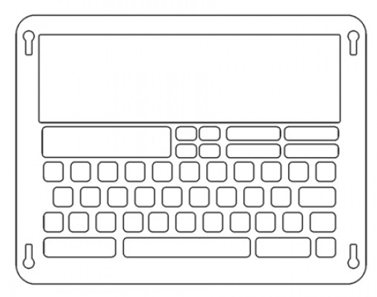
Description:
This keyguard matches the match the screen layout of the Verbally Augmentative and Alternative Communication iPad App.
More information at: Verbally Keyguard for IPad at Communicate AT
You can buy this accessory from Communicate AT

Is there any training available for these accessories?
Training and demonstrations might be available directly from retailers.
Some of these accessories might be displayed and available for demonstrations at Independent Living Centre Australia. Please contact ILC for further information.

