Smartwatches - Bluetooth

A smartwatch is a watch that is able to connect to your smart phone and activate some of its functions, such as making and receiving calls and messages, scheduling events, providing directions and check the weather. Some smartwatches also can and track your heart rate and other vital signs.
Standard Smartwatches connect to your smartphone vial Bluetooth. They can only make and receive calls and text messages when connected to the smartphone.
Type of accessory: Smartwatch
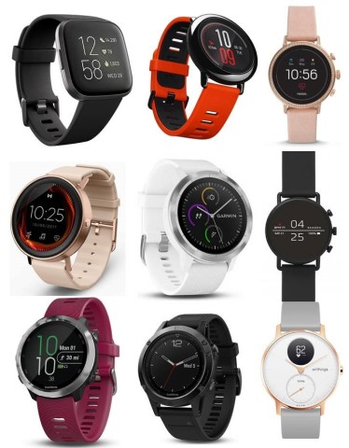

How do you use these accessories?
You can access the different functions and settings of your smartwatch by using their touchscreen, dials and buttons. Some brands allow you to speak commands to them.

Compatibility:
Apple smartwatches are currently only compatible with iPhones and iPads. While Smartwatches based on Google Wear operating system (former Android Wear OS) are compatible with Android phones from different brands, and they and can also have certain compatibility with Apple iPhones.
Please check compatibility of your smartwatch to your phone with your retailer before purchasing any smartwatch.

Popular Standard Smartwatches available in Australia:

AmazFit BIP

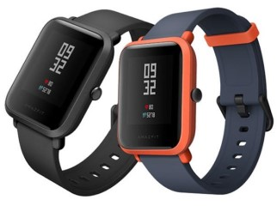
Compatibility: This product is compatible with Android and iPhone devices.

Features
- Built-in GPS and Bluetooth capabilities
- Display Characteristics options – adjustable brightness and screen timeout
- Heart-Rate and Activity Tracker
- Notifications – Text, email, social media, app alerts, alarm clock, and calendar alerts
- Screen Magnifier
- Personalised Shortcuts
- Visual and Vibrating Alerts - Incoming calls, messages, emails, or notifications
- Voice Notes and reminders
- Water resistance

You can buy this device from Dick Smith and Kogan.
More information at:
Amazfit BIP Web Page
Amazfit BIP FAQs Web Page
Amazfit BIP Quick User Guide Web Page

AmazFit Verge

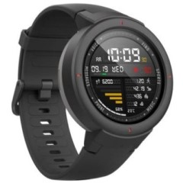
Compatibility: This product is compatible with Android and iPhone devices.

Features
- Battery Life of 5+ days
- Built-in GPS and Bluetooth capabilities
- Display Characteristics options – adjustable brightness and screen timeout
- Heart-Rate and Activity Tracker
- Make and receive calls on your write (via Bluetooth connection to phone)
- Notifications – Text, email, social media, app alerts, alarm clock, and calendar alerts
- Personal Assistant / Voice Control (Amazon Alexa)
- Personalised Shortcuts
- Screen Magnifier
- Visual and Vibrating Alerts - Incoming calls, messages, emails, or notifications
- Voice Notes and reminders
- Water resistance

You can buy this device from Dick Smith and Kogan.
More information at:
Amazfit Verge Web Page
Amazfit Verge FAQs Web Page

AmazFit Stratos

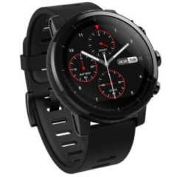

Compatibility: This product is compatible with Android and iPhone devices.

Features
- Battery life of 5+ days
- Built-in GPS, Wi-Fi and Bluetooth capabilities
- Display Characteristics options – adjustable brightness and screen timeout
- Heart-Rate and Activity Tracker
- Notifications – Text, email, social media, app alerts, alarm clock, and calendar alerts
- Screen Magnifier
- Personalised Shortcuts
- Visual and Vibrating Alerts - Incoming calls, messages, emails, or notifications
- Voice Notes and reminders
- Water resistance

You can buy this device from Dick Smith and Kogan.
More information at:
Amazfit Stratos Web Page
Amazfit Stratos FAQs Web Page
Amazfit Stratos Quick User Guide Web Page

AmazFit Pace

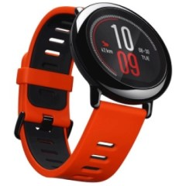
Compatibility: This product is compatible with Android and iPhone devices.

Features
- Built-in GPS and Bluetooth capabilities
- Display Characteristics options – adjustable brightness and screen timeout
- Heart-Rate and Activity Tracker
- Notifications – Text, email, social media, app alerts, alarm clock, and calendar alerts
- Screen Magnifier
- Personalised Shortcuts
- Visual and Vibrating Alerts - Incoming calls, messages, emails, or notifications
- Voice Notes and reminders
- Water resistance

You can buy this device from Dick Smith and Kogan.
More information at:
Amazfit Pace Web Page
Amazfit Pace FAQs Web Page
Amazfit Pace Quick User Guide Web Page

Diesel Full Guard 2.5 Smartwatch

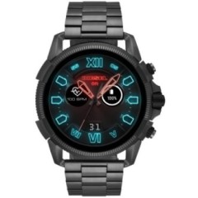

Compatibility: This product is compatible with phones that have Android OS 4.4+ (excluding Go Edition) and iOS 9.3+

Features
- Built-in GPS and Bluetooth capabilities
- Display Characteristics options – adjustable brightness and screen timeout
- Direct access to accessibility settings
- Google Pay
- Heart-Rate and Activity Tracker
- Notifications – Text, email, social media, app alerts, alarm clock, and calendar alerts
- Personal Assistant / Voice Control (Google)
- Screen Magnifier and LED Flashlight
- Personalised Shortcuts
- Speaker and microphone capable
- Visual and Vibrating Alerts - Incoming calls, messages, emails, reminders or notifications
- Voice Notes and reminders
- Water resistance

You can buy this device from Diesel, JB Hi-Fi, Myer, and Iconic.
More information at:
Diesel Full Guard 2.5 Smartwatch Web Page
Diesel Full Guard 2.5 Smartwatch Quick User Guide PDF
Diesel on Touchscreen Smartwatches

Diesel Mega Chief Hybrid Smartwatch

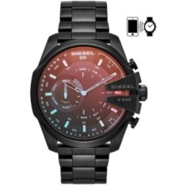

Compatibility: This product is compatible with phones that have Android OS 4.4+ (excluding Go Edition) and iOS 9.3+

Features
- Bluetooth capabilities
- Display Characteristics options – adjustable brightness and screen timeout
- Direct access to accessibility settings
- Heart-Rate and Activity Tracker
- No Charging – Six Month Battery
- Notifications – Text, email, social media, app alerts, alarm clock, and calendar alerts
- Personal Assistant / Voice Control (Google)
- Screen Magnifier and LED Flashlight
- Personalised Shortcuts
- Speaker and microphone capable
- Visual and Vibrating Alerts - Incoming calls, messages, emails, reminders or notifications
- Voice Notes and reminders
- Water resistance

You can buy this device from Diesel, Myer, and Iconic.
More information at:
Diesel Mega Chief Hybrid Smartwatch Web Page
Diesel Mega Chief Hybrid Smartwatch Quick User Guide PDF
Diesel on Hybrid Smartwatches

Diesel On Full Guard

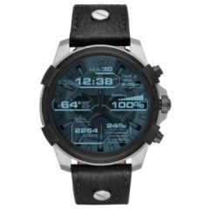

Compatibility: This product is compatible with phones that have Android OS 4.4+ (excluding Go Edition) and iOS 9.3+

Features
- Built-in GPS and Bluetooth capabilities
- Display Characteristics options – adjustable brightness and screen timeout
- Direct access to accessibility settings
- Heart-Rate and Activity Tracker
- Notifications – Text, email, social media, app alerts, alarm clock, and calendar alerts
- Personal Assistant / Voice Control (Google)
- Screen Magnifier and LED Flashlight
- Personalised Shortcuts
- Speaker and microphone capable
- Visual and Vibrating Alerts - Incoming calls, messages, emails, reminders or notifications
- Voice Notes and reminders
- Water resistance

You can buy this device from Diesel, and JB Hi-Fi.
More information at:
Diesel On Full Guard Smartwatch Web Page
Diesel On Full Guard Smartwatch Quick User Guide PDF
Diesel on Touchscreen Smartwatches

Fitbit Versa 2

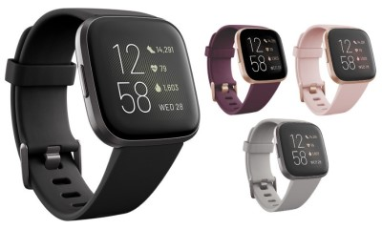

Compatibility: This product is compatible with Android and iPhone devices.

Features
- Always On display mode
- Click speed adjustments
- Display Characteristics options – Adjustable brightness and screen timeout
- GPS and Bluetooth capabilities
- Heart-Rate and Activity Tracker
- Notifications – call, text, calendar, and app notifications
- Personal Assistant / Voice Control (Alexa)
- Screen Magnifier
- Timers, reminders, and alarms built-in
- Visual and Vibrating Alerts - Incoming calls, messages or notifications
- Voice Notes and reminders
- Water resistance to 50 meters

You can buy this product from Fitbit Australia Harvey Norman, The Good Guys, Officeworks, Myer, JB Hi-Fi, and Rebel sport.

More information at:
Fitbit Versa Web Page
Fitbit Versa User Manual PDF

Fitbit Versa

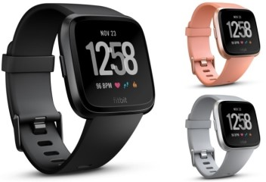

Compatibility: This product is compatible with Android and iPhone devices.

Features
- Click speed adjustments
- Display Characteristics options – Adjustable brightness and screen timeout
- GPS and Bluetooth capabilities
- Heart-Rate and Activity Tracker
- Notifications – call, text, calendar, and app notifications
- Screen Magnifier
- Visual and Vibrating Alerts - Incoming calls, messages or notifications
- Voice Notes and reminders
- Water resistance to 50 meters

You can buy this product from chain stores such as Harvey Norman, Target, Big W, Officeworks, Myer, JB Hi-Fi, Dick Smith, and Rebel sport.

More information at:
Fitbit Versa Web Page
Fitbit Versa User Manual PDF

Fitbit Versa Lite

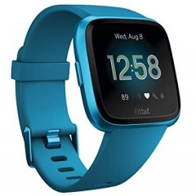

Compatibility: This product is compatible with Android and iPhone devices.

Features
- Click speed adjustments
- Display Characteristics options – Adjustable brightness and screen timeout
- GPS and Bluetooth capabilities
- Heart-Rate and Activity Tracker
- Notifications – call, text, calendar, and app notifications
- Screen Magnifier
- Visual and Vibrating Alerts - Incoming calls, messages or notifications
- Voice Notes and reminders
- Water resistance to 50 meters

You can buy this product from chain stores such as Harvey Norman, Target, Myer, JB Hi-Fi, Dick Smith, and Bing Lee.

More information at:
Fitbit Versa Web Page
Fitbit Versa Lite User Manual PDF

Fitbit Ionic

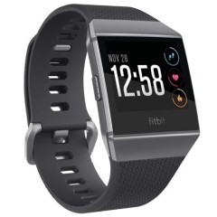

Compatibility: This product is compatible with Android and iPhone devices.

Features
- Click speed adjustments
- Display Characteristics options – Adjustable brightness and screen timeout
- GPS and Bluetooth capabilities
- Heart-Rate and Activity Tracker
- Notifications – call, text, calendar, and app notifications
- Screen Magnifier
- Visual and Vibrating Alerts - Incoming calls, messages or notifications
- Voice Notes and reminders
- Water resistance to 50 meters

You can buy this product from chain stores such as Harvey Norman, Target, Big W, Officeworks, Myer, JB Hi-Fi, Dick Smith, and Bing Lee.

More information at:
Fitbit Ionic Web Page
Fitbit Ionic User Manual PDF

Fossil Gen 4 Smartwatch

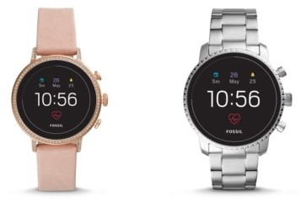

Compatibility: This product is compatible with phones that have Android OS 4.4+ (excluding Go Edition) and iOS 9.3+

Features
- Activity Tracker
- Display Characteristics options – adjustable brightness and screen timeout
- Direct access to accessibility settings
- GPS and Bluetooth capabilities
- Notifications – Text, email, social media, app alerts, multiple time zones, alarm clock, and calendar alerts
- Personal Assistant / Voice Control (Google)
- Screen Magnifier
- Personalised Shortcuts
- Speaker-phone capable
- Visual and Vibrating Alerts - Incoming calls, messages, reminders or notifications
- Voice Notes and reminders
- Water resistance

You can buy this device from Fossil, JB Hi-Fi, and Iconic.
More information at:
Fossil Gen 4 Smartwatch Web Page
Fossil Gen 4 Smartwatch Quick User Guide

Garmin Vivoactive 4/4S

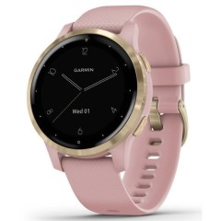
Compatibility: This product is compatible with Android and iPhone devices.
Both the 4 and 4S have the same features, the only difference is the 4S has a 40 MM screen size while the 4 is a 45 MM.
Features
- Calendar, weather, and music control on the watch
- Display Characteristics options – Adjustable brightness, screen timeout
- GPS and Bluetooth capabilities
- Heart-Rate and Activity Tracker – respiration rate, pulse oximeter acclimatisation, and breathing rate
- Text response/reject phone call with text (Android only)
- Visual and Vibrating Alerts - Incoming calls, messages or notifications
- Voice Assistant
- Voice Notes and reminders
- Water and dust resistance

You can buy this device from Garmin, JB Hi-Fi, and Harvey Norman.
More information at:
Garmin Vivoactive 4/4S Watch Web Page
Garmin Vivoactive 4/4S Watch User Manual (PDF Download)
Garmin Vivoactive 4/4S Watch 'How-to' videos Web Page

Garmin Vivoactive 3

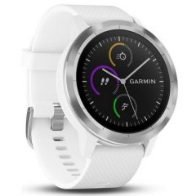
Compatibility: This product is compatible with Android and iPhone devices.

Features
- Calendar, weather, and music control on the watch
- Display Characteristics options – Adjustable brightness, screen timeout
- GPS and Bluetooth capabilities
- Heart-Rate and Activity Tracker
- Text response/reject phone call with text (Android only)
- Visual and Vibrating Alerts - Incoming calls, messages or notifications
- Voice Assistant
- Voice Notes and reminders
- Water and dust resistance

You can buy this device from Garmin, JB Hi-Fi, Officeworks, Harvey Norman, Rebel Sport, Dick Smith, and Kogan
More information at:
Garmin Vivoactive 3 Watch Web Page
Garmin Vivoactive 3 Watch User Manual PDF
Garmin Vivoactive 3 Watch 'How-to' videos Web Page

Garmin Forerunner 645

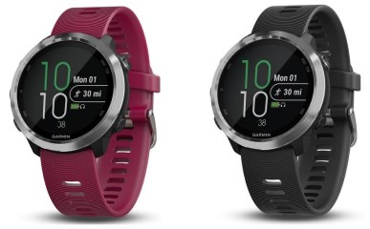
Compatibility: This product is compatible with Android and iPhone devices.

Features
- Audio Prompts
- Calendar, weather, and music control on the watch
- Display Characteristics options – Adjustable brightness, screen timeout
- Garmin Pay
- GPS and Bluetooth capabilities
- Heart-Rate and Activity Tracker
- Text response/reject phone call with text (Android only)
- Visual and Vibrating Alerts - Incoming calls, messages or notifications
- Voice Assistant
- Voice Notes and reminders
- Water and dust resistance

You can buy this device from JB Hi-Fi, Harvey Norman, Dick Smith, Rebel Sport, and Kogan.
More information at:
Garmin Forerunner 645 Watch Web Page
Garmin Forerunner 645 Watch User Manual PDF
Garmin Forerunner 645 Watch 'How-to' videos Web Page

Garmin Venu
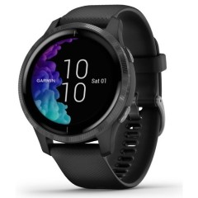
Compatibility: This product is compatible with Android and iPhone devices.
Features
- Audio Prompts
- Calendar, weather, and music control on the watch
- Display Characteristics options – Adjustable brightness, screen timeout
- Garmin Pay
- GPS, Bluetooth and Wi-Fi capabilities
- Heart-Rate and Activity Tracker – respiration rate, pulse oximeter acclimatisation, and breathing rate
- Safety and Tracking features – location can be sent to contacts either manually or automatically with built-in incident detection
- Text response/reject phone call with text (Android only)
- Visual and Vibrating Alerts - Incoming calls, messages or notifications
- Voice Assistant
- Voice Notes and reminders
- Water and dust resistance

You can buy this device from Garmin, JB Hi-Fi, Harvey Norman, and David Jones.
More information at:
Garmin Venu Watch Web Page
Garmin Venu Watch User Manual PDF
Garmin Venu Watch 'How-to' videos Web Page

Garmin Fenix 6 Series
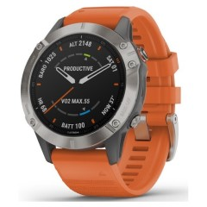
Compatibility: This product is compatible with Android and iPhone devices.
Features
- Audio Prompts
- Built-in Maps with directions
- Calendar, weather, and music control on the watch
- Display Characteristics options – Adjustable brightness, screen timeout
- Garmin Pay
- GPS, Bluetooth and Wi-Fi capabilities
- Heart-Rate and Activity Tracker – respiration rate, pulse oximeter acclimatisation, and breathing rate
- Solar charging
- Text response/reject phone call with text (Android only)
- Visual and Vibrating Alerts - Incoming calls, messages or notifications
- Voice Assistant
- Voice Notes and reminders
- Water and dust resistance

You can buy this device from Garmin, JB Hi-Fi, Harvey Norman, Kogan, Dick Smith, and Rebel Sport.
More information at:
Garmin Fenix 6 Watch Web Page
Garmin Fenix 6 Watch User Manual PDF
Garmin Fenix 6 Watch 'How-to' videos Web Page

Garmin Fenix 5 Series

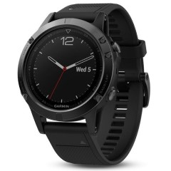

Compatibility: This product is compatible with Android and iPhone devices.
Features
- Audio Prompts
- Built-in Maps with directions (5X only)
- Calendar, weather, and music control on the watch
- Display Characteristics options – Adjustable brightness, screen timeout
- Garmin Pay
- GPS, Bluetooth and Wi-Fi capabilities
- Heart-Rate and Activity Tracker
- Text response/reject phone call with text (Android only)
- Visual and Vibrating Alerts - Incoming calls, messages or notifications
- Voice Assistant
- Voice Notes and reminders
- Water and dust resistance

You can buy this device from Garmin, JB Hi-Fi, Harvey Norman, Kogan, Dick Smith, and Rebel Sport.
More information at:
Garmin Fenix 5 Watch Web Page
Garmin Fenix 5 Watch User Manual PDF
Garmin Fenix 5 Watch 'How-to' videos Web Page

Garmin Fenix 5 plus Series

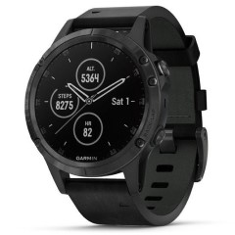

Compatibility: This product is compatible with Android and iPhone devices.
Features
- Audio Prompts
- Built-in Maps with directions (5X only)
- Calendar, weather, and music control on the watch
- Display Characteristics options – Adjustable brightness, screen timeout
- Garmin Pay
- GPS, Bluetooth and Wi-Fi capabilities
- Heart-Rate and Activity Tracker
- Text response/reject phone call with text (Android only)
- Visual and Vibrating Alerts - Incoming calls, messages or notifications
- Voice Assistant
- Voice Notes and reminders
- Water and dust resistance

You can buy this device from Garmin, JB Hi-Fi, Harvey Norman, Kogan, Dick Smith, and Rebel Sport.
More information at:
Garmin Fenix 5 plus Watch Web Page
Garmin Fenix 5 plus Watch User Manual PDF
Garmin Fenix 5 plus Watch 'How-to' videos Web Page

Garmin Vivomove HR Hybrid

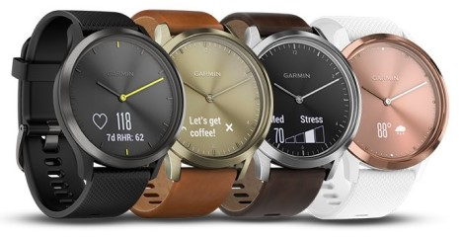

Compatibility: This product is compatible with Android and iPhone devices.
Features
- Audio Prompts
- Bluetooth and Wi-Fi capabilities
- Calendar, weather, and music control on the watch
- Display Characteristics options – Adjustable brightness, screen timeout
- Heart-Rate and Activity Tracker
- Visual and Vibrating Alerts - Incoming calls, messages or notifications
- Voice Notes and reminders
- Water and dust resistance
- Wellness monitoring tools – all-day stress tracking and a relaxation timer

You can buy this device from Garmin, Big W, Officeworks, JB Hi-Fi, Harvey Norman, Kogan, Dick Smith, and Rebel Sport.
More information at:
Garmin Vivomove HR Hybrid Watch Web Page
Garmin Vivomove HR Hybrid Watch User Manual PDF
Garmin Vivomove HR Hybrid Watch 'How-to' videos Web Page

Misfit Vapor

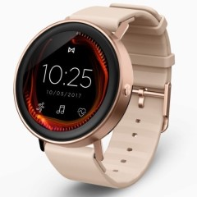
Compatibility: This product is compatible with phones that have Android OS 4.4+ (excluding Go Edition) and iOS 9.3+

Features
- Display Characteristics options – adjustable brightness and screen timeout
- Direct access to accessibility settings
- Bluetooth capabilities
- Google Pay
- Heart-Rate and Activity Tracker
- Notifications – Text, email, social media, app alerts, alarm clock, and calendar alerts
- Personal Assistant / Voice Control (Google)
- Screen Magnifier
- Personalised Shortcuts
- Speaker-phone capable
- Visual and Vibrating Alerts - Incoming calls, messages, emails, reminders or notifications
- Virtual Touch Bezel for easy scrolling and navigating
- Voice Notes and reminders
- Water resistance

You can buy this device from Misfit, Harvey Norman, and Iconic.
More information at:
Misfit Vapor Web Page
Misfit Vapor Quick User Guide PDF
Misfit Vapor FAQ Web Page

Misfit Vapor 2

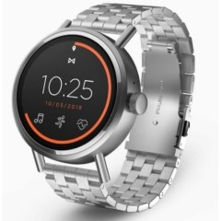

Compatibility: This product is compatible with phones that have Android OS 4.4+ (excluding Go Edition) and iOS 9.3+

Features
- Built-in GPS and Bluetooth capabilities
- Display Characteristics options – adjustable brightness and screen timeout
- Direct access to accessibility settings
- Google Pay
- Heart-Rate and Activity Tracker
- Notifications – Text, email, social media, app alerts, alarm clock, and calendar alerts
- Personal Assistant / Voice Control (Google)
- Screen Magnifier
- Personalised Shortcuts
- Speaker-phone capable
- Visual and Vibrating Alerts - Incoming calls, messages, emails, reminders or notifications
- Virtual Touch Bezel for easy scrolling and navigating
- Voice Notes and reminders
- Water resistance

You can buy this device from Misfit, JB Hi-Fi, and Iconic
More information at:
Misfit Vapor 2 Web Page
Misfit Vapor 2 Quick User Guide PDF
Misfit Vapor 2 FAQ Web Page

Samsung Gear S3 Frontier LTE

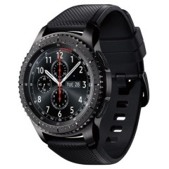

Features
- Activity Tracker
- Click speed adjustments
- Display Characteristics options – Adjustable brightness, screen timeout Contrast
- Enable direct access to accessibility settings
- GPS and Bluetooth
- Make calls from your wrist
- Messaging Options - Predictive text, MMS, IM, Email, and Text messaging/SMS
- Screen Magnifier
- SOS messages
- Speaker and microphone capable
- TalkBack - screen reader and voiced menus
- Text-to-speech setting - language, speech rate, notifications
- Touch sounds – Sound made when apps or options are selected
- Visual and Vibrating Alerts - Incoming calls, messages or notifications
- Voice Assistant
- Voice Notes and reminders
- Water and dust resistance

You can buy this device from JB Hi-Fi, Harvey Norman, and Samsung.
More information at:
Samsung Gear S3 Frontier Web Page
Samsung Gear S3 Frontier User Manual PDF
Samsung Gear S3 Frontier Support Web Page

Samsung Galaxy Watch Active

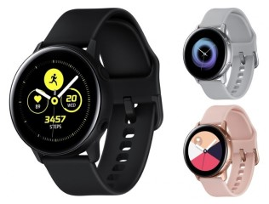
Compatibility: This product is compatible with phones that have Android OS 4.4+ and iOS 9.0+

Features
- Activity Tracker
- Click speed adjustments
- Display Characteristics options – Adjustable brightness, screen timeout
- Enable direct access to accessibility settings
- GPS and Bluetooth capabilities
- Make and receive calls from your wrist using Bluetooth
- Samsung Pay
- Screen Magnifier
- Speaker and microphone capable
- Text-to-speech setting - language, speech rate, notifications
- Touch sounds – Sound made when apps or options are selected
- View incoming messages and reply using voice-to-text, emoji, keyboard or quick responses using Bluetooth
- Visual and Vibrating Alerts - Incoming calls, messages or notifications
- Voice Assistant
- Daily Assistant: Voice Notes and reminders
- Water and dust resistance
- Wellbeing and Mindfulness settings

You can buy this device from Samsung and chain stores such as JB Hi-Fi, Harvey Norman, Bing Lee, Dick Smith, and Officeworks.
More information at:
Samsung Galaxy Watch Active Web Page
Samsung Galaxy Watch Active Support Web Page

Samsung Galaxy Watch 42mm Bluetooth

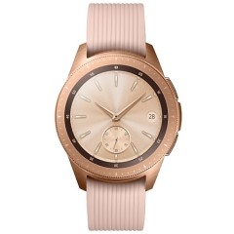
Compatibility: This product is compatible with phones that have Android OS 5.0+ and iOS 9.0+

Features
- Activity Tracker
- Click speed adjustments
- Display Characteristics options – Adjustable brightness, screen timeout
- Enable direct access to accessibility settings
- GPS and Bluetooth capabilities
- Make and receive calls from your wrist using Bluetooth
- Messaging Options - Predictive text, MMS, IM, Email, and Text messaging/SMS
- Samsung Pay
- Screen Magnifier
- SOS messages
- Speaker and microphone capable
- Text-to-speech setting - language, speech rate, notifications
- Touch sounds – Sound made when apps or options are selected
- Visual and Vibrating Alerts - Incoming calls, messages or notifications
- Voice Assistant
- Daily Assistant: Voice Notes and reminders
- Water and dust resistance

You can buy this device from Samsung and chain stores such as JB Hi-Fi, Harvey Norman, Bing Lee, Dick Smith, The Good Guys, and Officeworks.
More information at:
Samsung Galaxy Watch 42mm Bluetooth Web Page
Samsung Galaxy Watch 42mm Bluetooth User Manual PDF

Samsung Galaxy Watch 46mm Bluetooth

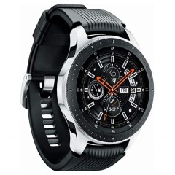
Compatibility: This product is compatible with phones that have Android OS 5.0+ and iOS 9.0+

Features
- Activity Tracker
- Click speed adjustments
- Display Characteristics options – Adjustable brightness, screen timeout
- Enable direct access to accessibility settings
- GPS and Bluetooth capabilities
- Make and receive calls from your wrist using Bluetooth
- Messaging Options - Predictive text, MMS, IM, Email, and Text messaging/SMS
- Samsung Pay
- Screen Magnifier
- SOS messages
- Speaker and microphone capable
- Text-to-speech setting - language, speech rate, notifications
- Touch sounds – Sound made when apps or options are selected
- Visual and Vibrating Alerts - Incoming calls, messages or notifications
- Voice Assistant
- Daily Assistant: Voice Notes and reminders
- Water and dust resistance

You can buy this device from Samsung and chain stores such as JB Hi-Fi, Harvey Norman, Bing Lee, Dick Smith, The Good Guys, and Officeworks.

More information at:
Samsung Galaxy Watch 46mm Bluetooth Web Page
Samsung Galaxy Watch 46mm Bluetooth User Manual PDF

Samsung Gear Sport

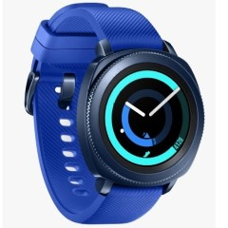
Compatibility: This product is compatible with phones that have Android OS 4.4+ and iOS 9.0+

Features
- Activity Tracker
- Click speed adjustments
- Display Characteristics options – Adjustable brightness, screen timeout
- Enable direct access to accessibility settings
- GPS and Bluetooth capabilities
- Make and receive calls from your wrist using Bluetooth
- Samsung Pay
- Screen Magnifier
- SOS Messages
- Speaker and microphone capable
- Touch sounds – Sound made when apps or options are selected
- View incoming messages and reply using voice-to-text, emoji, keyboard or quick responses using Bluetooth
- Visual and Vibrating Alerts - Incoming calls, messages or notifications
- Voice Assistant
- Daily Assistant: Voice Notes and reminders
- Water and dust resistance
- Wellbeing and Mindfulness settings

You can buy this device from Samsung and chain stores such as Harvey Norman, Dick Smith, Bing Lee, Big W, Myer, and online at Kogan.
More information at:
Samsung Gear Sport Web Page
Samsung Gear Sport User Guide PDF

Skagen Falster 2

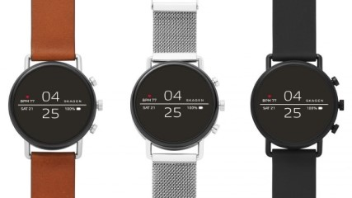

Compatibility: This product is compatible with phones that have Android OS 4.4+ (excluding Go Edition) and iOS 9.3+

Features
- Built-in GPS and Bluetooth capabilities
- Display Characteristics options – adjustable brightness and screen timeout
- Direct access to accessibility settings
- Google Pay
- Heart-Rate and Activity Tracker
- Notifications – Text, email, social media, app alerts, alarm clock, and calendar alerts
- Personal Assistant / Voice Control (Google)
- Screen Magnifier
- Personalised Shortcuts and customisable dials
- Speaker-phone capable
- Visual and Vibrating Alerts - Incoming calls, messages, emails, reminders or notifications
- Virtual Touch Bezel for easy scrolling and navigating
- Voice Notes and reminders
- Water resistance

You can buy this device from JB Hi-Fi, Myer, Iconic, Harvey Norman, and Asos.
More information at:
Skagen Falster 2 Web Page
Skagen Falster 2 Quick User Guide PDF
Skagen Falster 2 FAQ Web Page

TicWatch E (express)

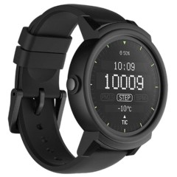

Compatibility: This product is compatible with phones that have Android OS 4.3+ (excluding Go Edition) and iOS 8.0+

Features
- Bluetooth capabilities
- Display Characteristics options – adjustable brightness and screen timeout
- Direct access to accessibility settings
- Heart rate and Activity Tracker
- Notifications – Text, email, social media, app alerts, multiple time zones, alarm clock, and calendar alerts
- Personal Assistant / Voice Control (Google)
- Screen Magnifier
- Personalised Shortcuts
- Speaker-phone capable
- Visual and Vibrating Alerts - Incoming calls, messages, reminders or notifications
- Voice Notes and reminders
- Water resistance

You can buy this device from Dick Smith and Kogan.
More information at:
Mobvoi TicWatch S&E Web Page
Mobvoi TicWatch E FAQs Web Page

TicWatch S (Sport)

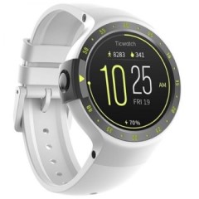

Compatibility: This product is compatible with phones that have Android OS 4.3+ (excluding Go Edition) and iOS 8.0+

Features
- Built-in GPS and Bluetooth capabilities
- Display Characteristics options – adjustable brightness and screen timeout
- Direct access to accessibility settings
- Heart rate and Activity Tracker
- Notifications – Text, email, social media, app alerts, multiple time zones, alarm clock, and calendar alerts
- Personal Assistant / Voice Control (Google)
- Screen Magnifier
- Personalised Shortcuts
- Speaker-phone capable
- Visual and Vibrating Alerts - Incoming calls, messages, reminders or notifications
- Voice Notes and reminders
- Water resistance

You can buy this device from Dick Smith and Kogan.
More information at:
Mobvoi TicWatch S&E Web Page
Mobvoi TicWatch E FAQs Web Page

Withings Steel HR

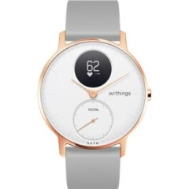

Compatibility: This product is compatible with phones that have Android OS 6+ and iOS 10+

Features
- Bluetooth capabilities
- Display Characteristics options – Adjustable brightness, screen timeout
- Heart-Rate and Activity Tracker
- Visual - Incoming calls, messages or notifications
- Voice Notes and reminders
- Water and dust resistance
- Wellness monitoring tools – all-day stress tracking and a relaxation timer

You can buy this device from JB Hi-Fi, Harvey Norman, Kogan, and Myer.
More information at:
Withings Steel HR Web Page
Withings Steel HR/ Steel HR Sport Support Web Page
Withings Steel HR/Steel HR Sport User Guide PDF
Withings Steel HR/Steel HR Sport Videos

Withings Steel HR Sport

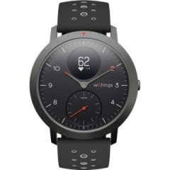

Compatibility: This product is compatible with phones that have Android OS 6+ and iOS 10+

Features
- Built-in GPS and Bluetooth capabilities
- Display Characteristics options – Adjustable brightness, screen timeout
- Heart-Rate and Activity Tracker
- Visual - Incoming calls, messages or notifications
- Voice Notes and reminders
- Water and dust resistance
- Wellness monitoring tools – all-day stress tracking and a relaxation timer

You can buy this device from JB Hi-Fi, Harvey Norman, and Kogan.
More information at:
Withings Steel HR Sport Web Page
Withings Steel HR/ Steel HR Sport Support Web Page
Withings Steel HR/Steel HR Sport User Guide PDF
Withings Steel HR/Steel HR Sport Videos

