Bluetooth Keyboards for Phones and Tablets
These accessories can be connected to mobile and tablet devices via Bluetooth to allow you to type using a physical keyboard rather than the screen or keys attached to the device. This is usual for people who have difficulty locating touchscreen keys or using small keyboards.

Type of accessory: Bluetooth Keyboard
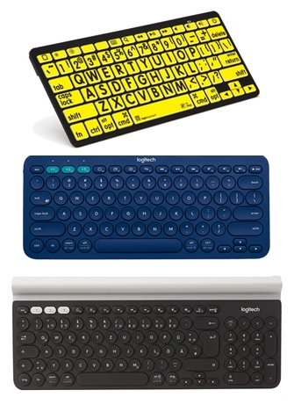

How do you use these accessories?
Pair this accessory to your mobile phone or tablet via Bluetooth, and then use it to type messages or other textual information into your smartphone or tablet.
Use this accessory to access the SMS or internet functions of your phone, or to contact the National Relay Service, on their SMS or Internet relay services.

These accessories connect to phones via:
Audio Jack: No
Bluetooth: Yes
Wi-Fi: No
Micro USB: No
Other: No

Is there any other piece of equipment required for this accessory to work properly with a phone?
No, these accessories are compatible with devices that allow Bluetooth and meet the operating system requirements of each device.

Compatibility:
Compatibility will vary depending on the operating system of the device and the accessory requirements. It is recommended that you check with the store or provider to ensure compatibility with your device.

Popular Bluetooth Keyboards available in Australia include:
Below are some Bluetooth keyboards.
There are many more available in Australia through reputable companies.

LargePrint Bluetooth Mini Keyboard
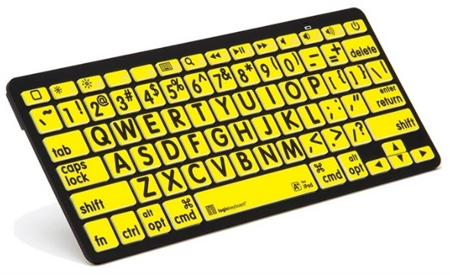
The Bluetooth Mini Keyboard is the first large print Bluetooth keyboard designed for vision impaired and mature-aged Apple iPad, iPhone, Mac or Android users. It features a large print QWERTY keyboard to input text into the phone and is suitable for Apple iPad, iPhone, iPod, and Android devices. It has an operating distance of up to 10m and comes in three colours: white on black, black on yellow, and black on white.
Compatibility: This device is compatible with devices with operating systems of iOS 6+, MAC OS 10.9+, and Android 4.4.4 +.
This accessory is available at Vision Australia and Quantum RLV
More Information at:
LogicKeyboard Bluetooth Mini Keyboard Mac Web Page
Apple Wireless Keyboard Compatibility

Logitech K380 Multi-device Bluetooth Keyboard
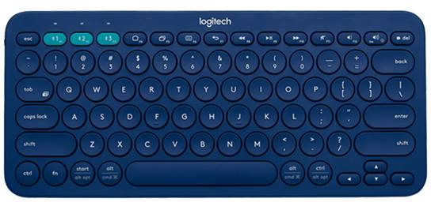
The Logitech K380 Multi-Device is a wireless keyboard that connects to all Bluetooth wireless devices that support external keyboards, including Windows, Mac, Chrome OS, Android and iOS. It allows you to connect to several devices at once and features Easy Switch buttons to let you change between devices quickly. It has an operating distance of 10m and is available in two colours.
Compatibility: This accessory is compatible with devices using Windows 7, 8, 10 or later, Mac OS 10.10 or later, or Chrome OS, as well as an operating system of iOS 5 or later and Android 3.2 or later.
This accessory is available at Logitech AU, JB Hi-Fi, Officeworks, Harvey Norman, The Good Guys, and Bing Lee.
More Information at:
Logitech K380 Web Page
Logitech K380 Setup Guide Web Page

Logitech K480 Multi-device Bluetooth Keyboard
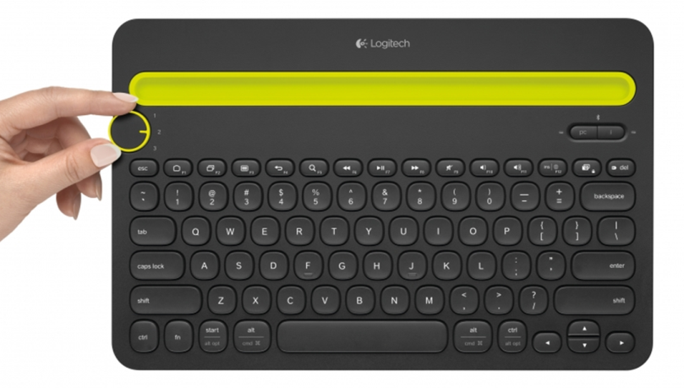
The Logitech K480 Multi-Device is a wireless desk keyboard that connects to your computer tablet and smartphone, working with Windows, Mac, Chrome OS, and Android and iOS devices. It allows you to connect to three devices at once and features an Easy Switch dial to let you change between devices quickly. It has an operating distance of 10m and is available in two colours
Compatibility: This accessory is compatible with devices using Windows 7, 8, 10 or later, Mac OS X or later, or Chrome OS, as well as an operating system of iOS 5 or later and Android 3.2 or later.
This accessory is available at Logitech AU, JB Hi-Fi, Officeworks, Harvey Norman, The Good Guys and Big W.
More Information at:
Logitech K480 Web Page
Logitech K480 Immersion/User Guide Web Page

Logitech K780 Multi-device Bluetooth Keyboard
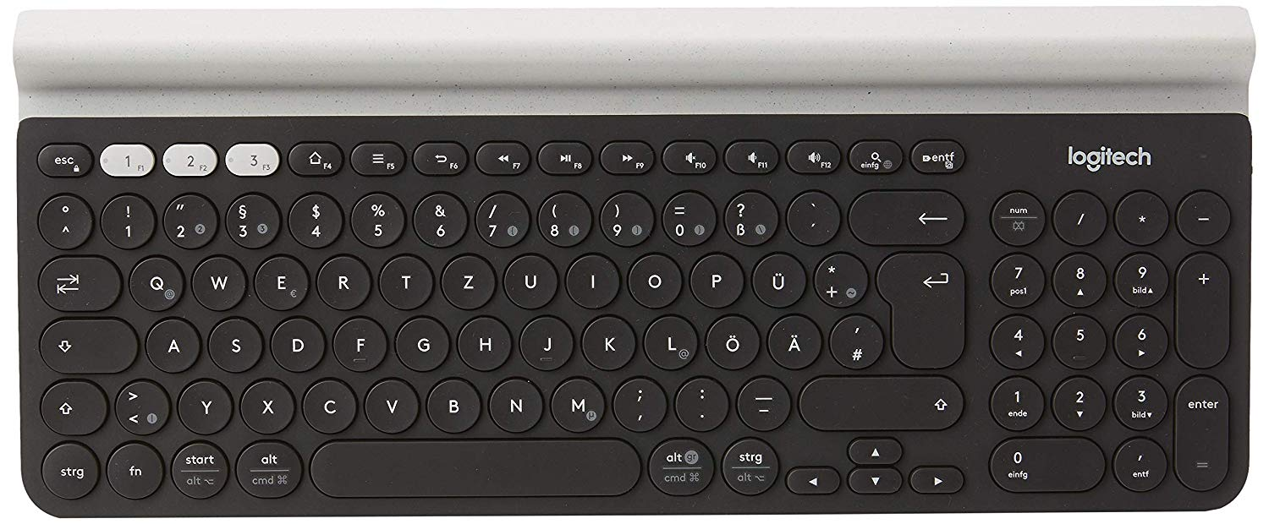
The Logitech K780 Multi-Device is a keyboard with numbers pad that connects with smartphones and tablets via Bluetooth and a USB port, working with Windows, Mac, Chrome OS, and Android and iOS devices. It allows you to connect to several devices at once and features Easy Switch buttons to let you change between devices quickly. It has an operating distance of 10m and features an integrated rubber cradle to hold mobile and tablet devices.
Compatibility: This accessory is compatible with devices using Windows 7, 8, 10 or later, Mac OS X 10.10 or later, or Chrome OS, as well as an operating system of iOS 5 or later and Android 5.0 or later.
This accessory is available at Logitech AU, JB Hi-Fi, Officeworks, Harvey Norman, Australia Post, and Myer.
More Information at:
Logitech K780 Web Page
Logitech K780 Setup Guide (PDF Download)

