Portable Wi-Fi Modems and Dongles
Portable Wi-Fi Modems and Dongles are devices that can connect to the internet mobile network delivered by cellular towers (3G, 4G and soon 5G). Once connected, they can cast a Wi-Fi signal that can be picked up by your tablet, computer or smart device so you can connect to the internet or use apps that are based on internet connectivity, such as voice, video and messaging apps.
These devices are particularly useful for people that need internet connectivity on the go, but their tablet, laptop or wearable does not have mobile internet capabilities.

Type of accessory: Mobile Broadband devices
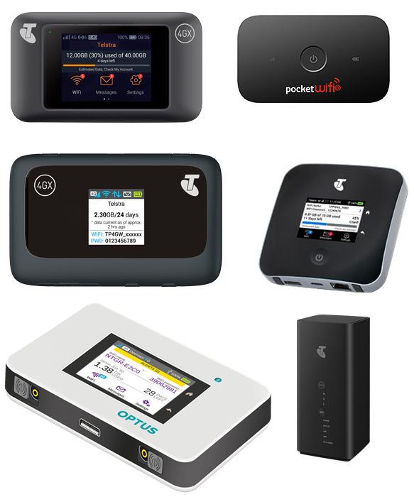

How do you use these accessories?
The Wi-Fi dongles and accessories shown in this document are currently provided on a plan from one of the major Australian Telecommunication providers. Once you have purchased your dongle and it is active on a plan, you can turn it on so they can connect to the mobile broadband network. Once they are connected to the network they will cast a Wi-Fi signal. Use your tablet or computer to connect to the Wi-Fi Signal from the dongle and access internet and apps.

These accessories connect to phones via:
Audio Jack: No
Bluetooth: Yes
Wi-Fi: Yes
Micro USB: No
Other: Ethernet Cable

Is there any other piece of equipment required for this accessory to work properly?
In general, these accessories do not need any additional piece of equipment to work properly. Make sure you select a dongle or modem that can connect directly to your tablet or laptop without the need for additional equipment.

Compatibility:
These accessories are compatible with most tablets, phones and computers in the market.

Accessibility Considerations:
These accessories usually relay on screens and visual indicators. Our advisors have indicated that people who are blind might want to look for dongles with physical buttons and without touchscreens.

Portable Wi-Fi Modems and Dongles available in Australia:

NETGEAR Nighthawk M2
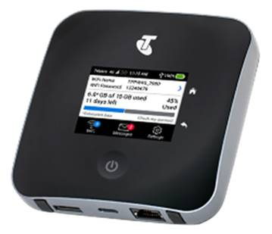
The NETGEAR Nighthawk M2 can be connected to any Bluetooth and Wi-Fi enabled device to allow for mobile internet connection. It features a physical on/off button and touch screen to access messages and connection information.
Key features:
  - Conveniently connect up to 20 Wi-Fi enabled devices plus one Ethernet device.
  - LCD touch screen with integrated data usage meter.
  - Battery life up to 16 hours.
  - Faster high quality Wi-Fi, ideal for streaming video, gaming and high speed data transfer.
  - JumpBoost feature to charge smartphones and small portable devices.
  - Simple set up with no software installation.
More Information at: NETGEAR Nighthawk M2 Web Page
You can buy this accessory from Telstra.

Telstra 4GX Wi-Fi Pro Modem
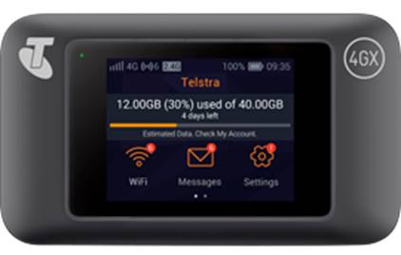
The Telstra 4GX Wi-Fi Pro can be connected to any Bluetooth and Wi-Fi enabled device to allow for mobile internet connection. It features touch screen to access messages and connection information and a physical on/off button.
Key features:
  - Connect up to 10 Wi-Fi enabled devices simultaneously including a compatible smartphone, tablet or laptop
  - Up to 11 hours of battery life
  - Colour LCD touch screen for monitoring your connection status and estimated data usage
  - Adjust settings and view estimated data and the web interface
  - Increase Wi-Fi performance and reduce interference with 802.11 AC and simultaneous dual-band Wi-Fi 2.4 & 5 GHz
More Information at: Telstra 4GX Wi-Fi Pro Web Page
You can buy this accessory on a plan from Telstra and prepaid from Officeworks with 5 GB of data for use in Australia within 30 days.

Telstra 4GX Modem
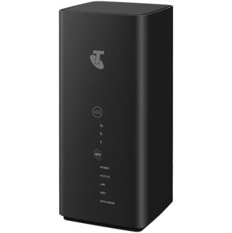
The Telstra 4GX Modem can be connected to any Wi-Fi enabled device to allow for mobile internet connection. It features a WPS physical button, and lights that indicate data usage and connectivity
Key features:
  - Connects up to 20 Wi-Fi enabled devices simultaneously such as your compatible smartphone, tablet or laptop
  - WI-FI 802.11ac for faster high quality Wi-Fi, ideal for streaming video , gaming and high speed data transfer
  - Adjust setting, receive SMS messages and monitor data from the home screen
  - LED that provides your estimated data usage
  - Comes pre-configured; there is no complicated set-up requirements. (customers still have to put a sim in) before they can use
More Information at: Telstra 4GX Wi-Fi Pro Web Page
You can buy this accessory on a plan from Telstra.

Telstra 4GX Wi-Fi Plus Modem MF910Y
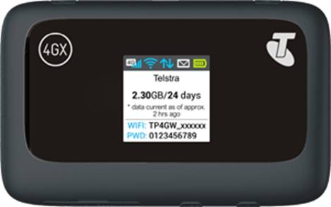
The Telstra 4GX Wi-Fi plus Modem can be connected to any Wi-Fi enabled device to allow for mobile internet connection. It features a display screen and physical WPS, Power, and Reset buttons
Key features:
  - Connect up to 10 Wi-Fi enabled devices simultaneously including a compatible smartphone, tablet or laptop.
  - Battery life up to 8 hours
  - Colour LCD screen to monitor connection status, and view your estimated pre-paid data usage
  - Adjust setting from the web interface
More Information at:
ZTE Telstra MF910Y Web Page
ZTE Telstra MF910Y User Guide (PDF Download)
You can buy this accessory prepaid from Telstra and Officeworks.

AC800S 4G Wi-Fi Modem
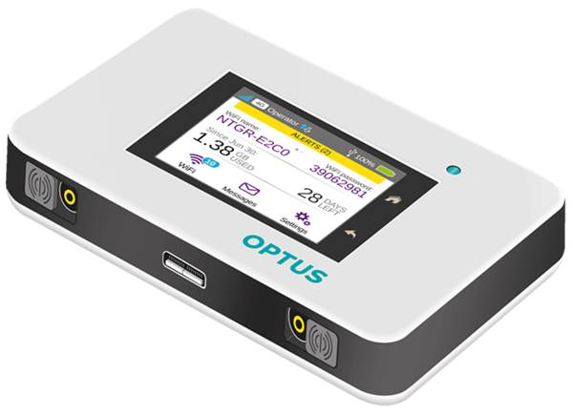
The AC800S 4G Wi-Fi Modem can be connected to any Wi-Fi enabled device to allow for mobile internet connection. It features a physical Power button and touch screen to view hotspot status, change settings and control connections.
Key features:
  - Connects up to 15 Wi-Fi Devices: Smartphones, tablets, laptops, e-readers, printers, portable gaming consoles, digital camera and more
  - Battery life up to 11 hours of continuous use
  - LCD Touchscreen to conveniently monitor data usage, manage device and network settings
  - Jump boost your smartphones and small portable USB devices using the unique jump boost feature
  - Optus 4G Plus capable.
More Information at:
NETGEAR AC800S Web Page
Optus 800S Start up Guide (PDF Download)
You can buy this accessory on a plan from Optus.

Vodafone Pocket Wi-Fi 2 4G
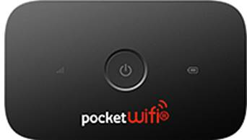
The Vodafone Pocket Wi-Fi 2 4G can be connected to any Wi-Fi enabled device to allow for mobile internet connection. It features a physical Power button.
Key features:
  - Connects up to 16 Wi-Fi devices
  - Battery life up to 6 hours of continuous use
  - Easy set-up and implementation
  - Compatible with Windows and Mac devices
More Information at:
Vodafone Pocket Wi-Fi 2 Web Page
Vodafone Pocket Wi-Fi 2 User Guide
You can buy this accessory on a plan from Vodafone.

