Speech Generating and Augmentative and Alternative Communication (AAC) Devices
These accessories allow individuals with speech, physical or cognitive impairments to use alternative forms of communication to make a call, send a message or use social media. Some devices have 3G capabilities while others can connect to your mobile via Bluetooth, allowing you to use AAC to send text messages or speech synthesised voice over a phone call. Each accessory offers different variations in how the speech in generated, ranging from visual inputs to eye gaze control, with some allowing you to receive the audio of the call through the speakers on the communication board.
Each accessory has different features that will suit various needs; please consult your health care professional and the accessory provider for further information on which type is most suitable for your requirements. Additionally, while there are many versions of these accessories available on the market, we have only included a few versions which are recognised as being used for mobile communication purposes.
Type of accessory: Communication Boards
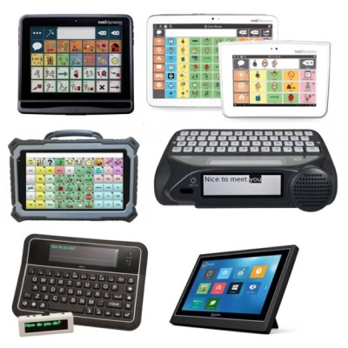

How do you use these accessories?
Each accessory allows for different forms of communication, speech generation, and typing. They will connect to the Wi-Fi, 3G capabilities or your mobile device via Bluetooth and allow you to make a call using a synthesised voice or send a text that is translated from an alternative form of communication, such as visual inputs.

These accessories connect to phones via:
Audio Jack: No
Bluetooth: Yes
Wi-Fi: No
Micro USB: No
Other: No

Is there any other piece of equipment required for this accessory to work properly with a phone?
No, most accessories will work directly with a compatible mobile device. However additional equipment can be acquired to improve the features and useability of some accessories.

Compatibility:
Each communication board is compatible with different mobile devices and operating systems. Contact the accessory provider to check which features will work with your device and whether you will be able to make calls.

AAC Devices with Cellular Capability:

Jabbla Allora 2
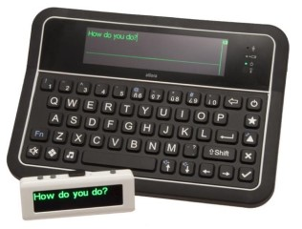
The Allora is a keyboard and switch accessible, text to speech, communication device, designed to meet the needs of people that are literate, who have reduced or little ability to speak and whose motor skills require a device that can adapt to change but maintain access for the user.
This device is compatible with a 3G sim card, meaning it can operate as a standalone communication device that can send SMS messages; transfer of data to computer is straight-forward and permits document formatting or printing. It does not allow for phone calls to be made.
It features a detachable display which can be hung around your neck to keep the focus on the user and not the device, adjustable displays and font, additional keyguards, versatile mounting capabilities, and switch/scanning access.
More information at:
Jabbla Allora 2 Web Page
Jabbla Allora 2 User Manual (PDF Download)
You can buy this accessory from Zyteq or enquire after a hire version from the Independent Living Centre (ILC).

Liberator Rugged 7
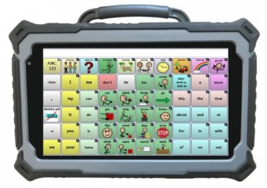
The Rugged 7 is designed to be a durable, dust and fluid resistant AAC communication device that can be used to generate voice output or send messages. It allows allow individuals with cognitive, physical, and speech impairments to easily engage in daily communication through generated speech. It uses NOVA and LAMP Words for Life Language Software, allowing for alphabet/text, symbol, and visual scene based inputs, and includes Ivona and Acapella voice outputs.
It features a carry handle, attached Bluetooth speakers, and Wi-Fi capabilities. Additionally, a SIM can be purchased so the device can act as a mobile communication device without having to connect to your mobile. You can also use any Android application required, with 3G and Wi-Fi capabilities allowing you to access additional social media and communication platforms to send and receive e-mails, online chat or Skype.
More information at:
Liberator Rugged 7 Web Page
Liberator Device Trials Web Page
Liberator Rugged 7 Quick Reference Guide (PDF Download)
You can buy the Rugged 7 online from Liberator or enquire after a hire version from the Independent Living Centre (ILC).

AAC Devices without Cellular Capability:

Abilia Lightwriter SL50
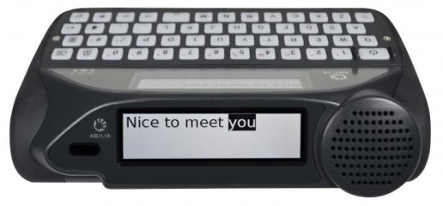
The Lightwriter SL50 is a text-to-speech device for literate users who are unable to communicate effectively through speech. Its key features include:
- Dual screens to allow both parties to see what you want to say
- Loud clear speech
- Simple menu with reduced distracting apps or loading times
- Small, portable and lightweight for on-the-go use
- Adjustable keyguards
- Two switches and keys that light up so that words can be typed and speech generated with limited mobility
This accessory also allows you to connect to your mobile device via Bluetooth to make and receive phone calls on Bluetooth-enabled devices. The Lightwriter SL50 has a built-in microphone, so you can talk and make sounds during the call or use the text and talk functions. The generated speech is received by the caller through the phone and their response is heard through the Lightwriter speakers.
Additionally, for compatible Android mobile phones, you can make and receive text messages through the Lightwriter so you do not need to swap between devices.
For more information:
Abilia Lightwriter SL50 Web Page
Abilia Lightwriter SL50 Video (YouTube)
Lightwriter SL50 Quick Guide (PDF Download)
Lightwriter SL50 User Manual (PDF Download), see pages 23-27 for instructions on making and receiving calls and texts.
You can buy this accessory online from Zyteq.

Jabbla Mobi 3
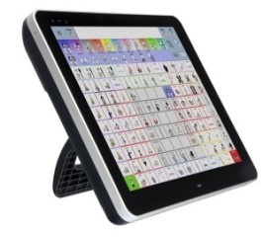
The Mobi 3 is a communication device and accessible tablet that is powered Mind Express 4 and Windows 10 and allows users to communicate via text or symbols. Communication can be made directly from person to person, via the internet or by phone through Bluetooth connection.
It features dual switches and two USB outlets, allowing for multiple methods of access including the touch screen, keyguards, and switch access via USB or Bluetooth switches. Additionally, the device can be purchased with the Alea IntelliGaze eye gaze accessory to allow the device to be controlled using eye movements alone.
It is available with a capacitive or resistive touch screen to suit your needs, and a rear and front camera. The Mobi 3 is also compatible with the Grid 3 software at an additional cost.
More information at:
Jabbla Mobi 3 Web Page
Mobi 3 User Manual (PDF Download)
You can buy the Mobi 3 online from Zyteq and the Mobi 3 with IntelliGaze from Zyteq or enquire after a hire version from the Independent Living Centre (ILC).

Jabbla Tellus i5
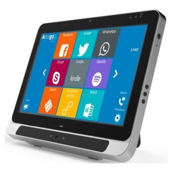
The Tellus i5 is a tablet-like device that has an integrated eye tracking device (EyeTech TM5), allowing individuals with physical impairments to control the device, environment and communicate using only their eyes.
It includes Intel i5 processor and Windows 10 operating system to allow you to use a variety of communication and social media applications. It is designed for multiple methods of access, so the device can be controlled using the touch screen, keyguards, switch access via USB or Bluetooth switches, as well as eye gaze accessories.
Additionally, it is compatible with a Wi-Fi, Bluetooth, and a SIM card allowing you to make phone calls and connect to the internet from the device.
More information at:
Jabbla Tellus i5 Web Page
Tellus i5 User Manual (PDF Download)
You can buy the Grid Pad 12 online from Zyteq or enquire after a hire version from the Independent Living Centre (ILC).

Liberator Accent Series
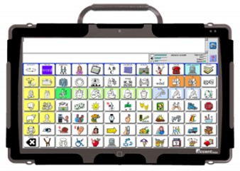
The Accent AAC tablet comes in three models: the Accent 800, Accent 1000, and Accent 1400 varying only in screen size and weight. They come pre-loaded with the NuVoice communication software which offers Unity and LAMP Words for Life page sets, with Essence, EasyChat, WordPower and Grid 3 being optional.
They feature built-in speakers for extra volume, cameras on the front and back, and a carry handle. They are also compatible with alternative access methods such as switching, joystick or mouse options, and NuPoint HeadPointing, with Eye Gaze enabled for the Accent 1000 and Accent 1400.
The Accent devices allow individuals with cognitive, physical, and speech impairments to easily engage in daily communication through generated speech. You can also use any Windows 10 application required, allowing you to access additional social media and communication platforms to send and receive e-mails, online chat or Skype.
More information at:
Liberator Accent Web Page
Liberator Device Trials Web Page
Liberator Device Manuals Web Page
You can buy the Accent 800 online from Liberator or enquire after a hire version from the Independent Living Centre (ILC).
You can buy the Accent 1000 online from Liberator or enquire after a hire version from the Independent Living Centre (ILC).
You can buy the Accent 1400 online from Liberator or enquire after a hire version from the Independent Living Centre (ILC).

Liberator Chat Fusion Series
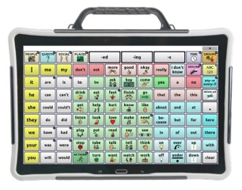
The Liberator Chat Fusion Series consists of the Chat Fusion 8 and Chat Fusion 10, which differ only in screen size and weight. They are AAC devices that offer multiple access options, wireless charging, and Chat software to help individuals with physical, cognitive, and speech impairments to communicate effectively.
These devices are compatible with multiple access methods including built-in compatibility with keyguards, single or dual switch features, and advanced scanning, as well as the option to add-on ChatPoint HeadPointing to allow for head tracking control. It also features a carry handle, stand, wheelchair mounting plate, and shoulder strap options, as well as wireless charging to ensure individuals with fine motor or vision impairments can place the device on the charging base.
They use NOVA and LAMP Words for Life Language Software, allowing for alphabet/text, symbol, and visual scene based inputs, and includes Ivona and Acapella voice outputs.
These devices use an Android Operating System and have Wi-Fi capabilities allowing users to access any Android application and use additional social media and communication platforms to send and receive e-mails, online chat or Skype.
More information at:
Liberator Chat Fusion Web Page
Liberator Device Trials Web Page
Liberator Chat Fusion 10 Quick Reference Guide (PDF Download)
You can buy the Chat Fusion 8 online from Liberator or enquire after a hire version from the Independent Living Centre (ILC).
You can buy the Chat Fusion 10 online from Liberator or enquire after a hire version from the Independent Living Centre (ILC).

Liberator NOVA Chat Series
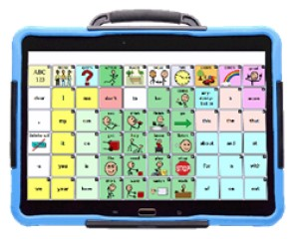
The NOVA Chat Series includes four models that vary with screen size and portability. In order of size, these are the Chat 5, Chat 8, Chat 10, and Chat 12. They use the NOVA chat software allowing for alphabet/text, symbol, and visual scene based inputs, and include the Ivona and Acapella voice outputs.
Each model allows for switch scanning access options, with the NOVA chat 8, 10, and 12 also compatible with Keyguards. Additionally, they all have multiple position capabilities and Social Chat options.
These devices allows individuals with cognitive, physical, and speech impairments to easily engage in daily communication through generated speech, as well as effortlessly connect with others via e-mail, text messaging, chat, Skype or through phone calls using Bluetooth technology.
More information at:
Liberator NOVA Chat Web Page
Liberator Device Trials Web Page
Liberator NOVA Chat User Guide (PDF Download)
You can buy the NOVA Chat 5 online from Liberator or enquire after a hire version from the Independent Living Centre (ILC).
You can buy the NOVA Chat 8 online from Liberator or enquire after a hire version from the Independent Living Centre (ILC).
You can buy the NOVA Chat 10 online from Liberator or enquire after a hire version from the Independent Living Centre (ILC).
You can buy the NOVA Chat 12 online from Liberator or enquire after a hire version from the Independent Living Centre (ILC).

Tobii Dynavox I-110
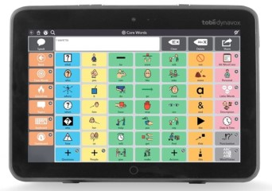
The Tobii Dynavox I-110 is a speech generating devices for Augmentative and Alternative Communication needs. It features a purpose-built, ultra-rugged design, Gorilla Glass, naturally intuitive user interface, and an IP54 classification.
It allows individuals with cognitive, physical, and speech impairments to easily engage in daily communication through generated speech, as well as effortlessly connect with others via e-mail, text messaging, chat, Skype or through phone calls using Bluetooth technology.
The I-110 comes with a full range of communication software solutions pre-installed, including Snap™ + Core, so that different levels of communication needs can be met. In particular, emergent communicators will use Snap Scene before moving into symbol-based communication on Snap + Core First to improve speed. Additionally, a literate, independent individual can use the Communicator 5 which provides advanced user functionality
This device can be connected via Bluetooth to your mobile device, allowing you to send or receive calls or texts using synthetic or natural speech. You can also use any Windows 10 application required, allowing you to access additional social media and communication platforms.
The I-110 device support a range of mobile devices using an Android OS, with a list of tested and approved devices found at Tobii Dynavox FAQ Web Page.
More information at:
Tobii Dynavox I-110 Web Page
Tobii Dynavox I-110 Brochure (PDF Download)
You can buy this accessory online from Link Assistive or enquire after a hire version from the Independent Living Centre (ILC).

Tobii Dynavox Indi Series
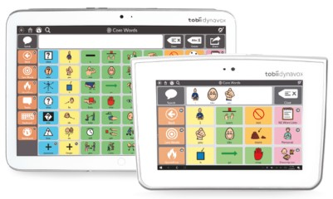
The Tobii Dynavox Indi 7 and Tobii-Dynavox Indi 10 are speech generating devices designed to meet all Augmentative and Alternative Communication needs. They are both available with Snap + Core First software, with the main variation being the screen size. They feature built-in speakers for extra volume, cameras on the front and back, and infrared for environmental controls
These devices allow individuals with cognitive, physical, and speech impairments to easily engage in daily communication through generated speech, as well as effortlessly connect with others via e-mail, text messaging, chat or Skype using Bluetooth technology. You can also use any Windows 10 application required, allowing you to access additional social media and communication platforms.
The Indi devices adapt to your access method with numerous compatible inputs, such as add-on switch ports, head-mouse, and touch with keyguards, and so on.
More information at:
Tobii Dynavox Indi 7 Web Page
Tobii Dynavox Indi 10 Web Page
Tobii Dynavox Indi Series Brochure (PDF Download)
You can buy the Indi 7 online from Link Assistive or enquire after a hire version from the Independent Living Centre (ILC).
You can buy the Indi 10 online from Link Assistive or enquire after a hire version from the Independent Living Centre (ILC).

Tobii Dynavox I-Series+
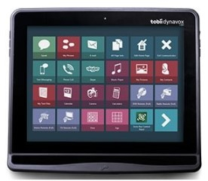
The Tobii Dynavox I-12+ and Tobii Dynavox I-15+ are speech generating devices that can be controlled through touch, external switches, eye gaze interaction, and more. It allows individuals with cognitive, physical, and speech impairments to easily engage in daily communication through generated speech, as well as effortlessly connect with others via e-mail, text messaging, chat, Skype or through phone calls using Bluetooth technology.
These accessories can be connected via Bluetooth to your mobile device, allowing you to send or receive calls or texts using synthetic or natural speech. You can also use any Windows 7 application required, allowing you to access additional social media and communication platforms. It also features front-facing and back-facing cameras, versatile mounting capabilities, and a scratch resistant touch screen.
The I-Series+ devices support a range of mobile devices using an Android OS, with a list of tested and approved devices found at Tobii Dynavox FAQ Web Page. Further, you can choose to purchase addition eye gaze hardware to allow for communication using only eye movements.
More information at:
Tobii Dynavox I-Series+ Web Page
Tobii Dynavox I-Series+ Product Leaflet (PDF Download)
You can buy this accessory online from Link Assistive or enquire after a hire version from the Independent Living Centre (ILC).

Smartbox Grid Pad Go
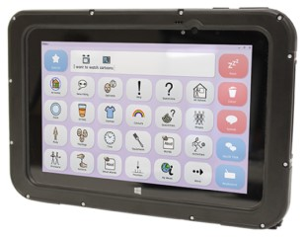
The Grid Pad Go 8 and Grid Pad Go 10 are Windows 10 tablets operating with Grid 3 software, allowing for AAC communication. They allow for alternative firms of communication and speech generation using Australian Acapela child and adult voices.
These devices can connect to Wi-Fi and Bluetooth (for use with Bluetooth speakers) and can be controlled using the touch screen, keyguards to suit specific needs, switch access via USB or Bluetooth switches, as well as mountable accessories. The devices operate on Windows 10, allowing Windows 10 applications to be downloaded and used, giving access to communication and social media apps.
The Grid 3 software allow users to communicate using given or customised grid sets, and generate messages using symbols, core words or text-to-speech, as well as connect with a mobile phone.
More information at:
Grid Pad Go Instruction Manual (PDF Download)
You can buy the Grid Pad Go 8 online from Zyteq or enquire after a hire version from the Independent Living Centre (ILC).
You can buy the Grid Pad Go 10 online from Zyteq or enquire after a hire version from the Independent Living Centre (ILC).

Smartbox Grid Pad 12
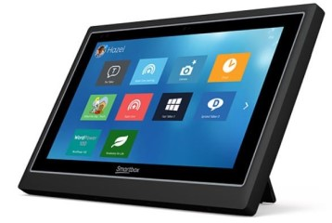
The Grid Pad 12 is a Windows 10 tablet operating with Grid 3 software, allowing for AAC communication. The Grid Pad 12 is compatible with Wi-Fi and Bluetooth, and features built-in radio, infrared Environment Control, and mountable options.
It is designed for multiple methods of access, so the device can be controlled using the touch screen, keyguards, switch access via USB or Bluetooth switches, as well as eye gaze accessories such as the EyeTech TM5 and Irisbond Duo camera. It includes two built-in ports for switches and a headphone jack.
The Grid Pad 12 operate on Windows 10, allowing Windows 10 applications to be downloaded and used, giving access to communication and social media apps.
The Grid 3 software allow users to communicate using given or customised grid sets, and generate messages using symbols, core words or text-to-speech, as well as connect with a mobile phone.
More information at:
Grid Pad 12 Think Smart Box Web Page
Grid Pad Go User Manual (PDF Download)
You can buy the Grid Pad 12 online from Zyteq or enquire after a hire version from the Independent Living Centre (ILC).

Is there any training available for these accessories?
  - Training and demonstrations might be available directly from retailers.
  - Some of these accessories might be displayed and available for demonstrations at Independent Living Centre Australia or through the providers. Please contact ILC and relevant providers for further information.

