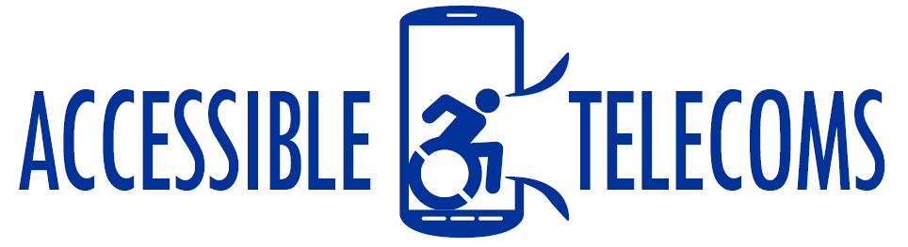

Augmentative and Alternative Communication (AAC) Applications
Augmentative and Alternative Communication (AAC) refers to the tools and strategies used to assist people who have little or no speech to communicate. AAC apps assist individuals in forming phrases and sentences using symbols and predictive keyboards. These can then be copied to communication apps or web pages to allow for improved communication of needs and wants.
These applications are useful for non-verbal people with Autism, Down syndrome, Amyotrophic Lateral Sclerosis (ALS – Lou Gehrig’s disease), cerebral palsy, apraxia, and a range of other diagnoses. However, each individual will require different symbols, layout, and speech and voice option, thus the AAC app selected should be trialled and adapted to the individual’s needs to ensure effective communication.
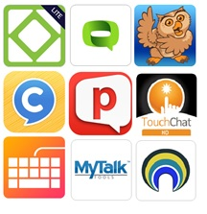
Type of accessory: Application

Access Needs:
- Cognitive
- Physical
- Speech

Compatibility:
- Each application will require a different operating system. While some apps are design to suit particular keyboards or have compatible key guards, the following apps do not require additional hardware to be used.

AAC Applications:

Apple IOS Compatible

Sono Flex Lite
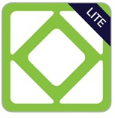
Tobii Sono Flex is an easy to use AAC vocabulary app that turns symbols into clear speech. It offers language to nonverbal users who are not yet in full control of literacy. The Lite version differs from the paid version in that there is a limit on the preprogramed contexts available and reduced customisation settings.
Compatibility: Requires iOS 9.0 or later.
Prices: Free
More information at: Tobii Sono Flex App Web Page.
You can download this application from the Apple App Store.

MyTalkTools Mobile Lite
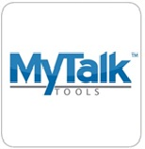
The app transforms a mobile tablet/phone into an Augmentative and Alternative Communication (AAC) device for those who are unable to produce understandable natural speech on their own. The Lite version has limited features, allowing for a trial of the app only before purchasing.
Compatibility: Requires iOS 9.0 or later
Prices: Free
More information at: MyTalkTools Mobile App Web Page
You can download this application from the Apple App Store.

QuickTalk AAC
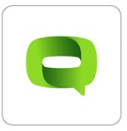
The Quick Talk AAC app is a comprehensive AAC application designed by educators, therapists, engineers, and parents to help individuals who are non-verbal to communicate through images, profiles, and symbols.
Compatibility: Requires iOS 9.0 or later.
Prices: $38.99 as at the 04/07/2019
More information at: Edshelf Quick Talk AAC Review Web Page.
You can download this application from the Apple App Store.

Sono Flex
Tobii Sono Flex is an easy to use AAC vocabulary app that turns symbols into clear speech. It offers language to nonverbal users who are not yet in full control of literacy.
Compatibility: Requires iOS 9.0 or later.
Prices: $159.99 as at the 04/07/2019
More information at: Tobii Sono Flex App Web Page.
You can download this application from the Apple App Store.

MyTalkTools Mobile – Paid (Lite version is Free)
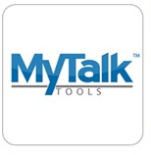
The app transforms a mobile tablet/phone into an Augmentative and Alternative Communication (AAC) device for those who are unable to produce understandable natural speech on their own.
Compatibility: Requires iOS 9.0 or later
Prices: $159.99 as at the 04/07/2019
More information at: MyTalkTools Mobile App Web Page
You can download this application from the Apple App Store.

Keeble – Paid
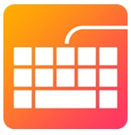
This app offers an accessible keyboard which can be fully customised and used with almost any iOS app, allowing for easier and faster typing and communication for people with physical, cognitive, and vision impairments.
Compatibility: Requires iOS 9.0 or later
Prices: $159.99 as at the 04/07/2019
More information at: Keeble Mobile App Web Page
You can download this application from the Apple App Store.

ChatAble App – Paid
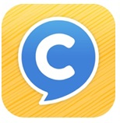
ChatAble provides a grid of symbols that can be pressed to speak words and construct sentences, designed for children, teenagers and adults who are unable to write or speak.
Compatibility: Requires iOS 10.0 or later
Prices: $159.99 as at the 04/07/2019
More information at: ChatAble App Therapy Box Web Page
You can download this application from the Apple App Store

TouchChat HD– Paid
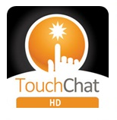
TouchChat HD is a full-featured communication solution that allows non-verbal individuals to create words, phrases, and messages using synthesised or digitised speech. TouchChat can be customised to suit individual needs, has a library of over 10,000 symbol stix, four pre-programmed vocabulary organisations, and uses spelling with basic word prediction.
Compatibility: Requires iOS 9.0 or later.
Prices: $229.99 as at the 04/07/2019
More information at: TouchChat App Web Page.
You can download this application from the Apple App Store.

Proloquo2Go – Paid
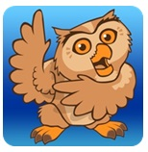
The Proloquo2Go is an AAC and text-to-speech app that is completely customizable and designed for a range of fine-motor and visual skills, making it useful for non-verbal people with a range of other diagnoses. This app allows individuals to customise their own buttons, up to 25,000 symbols or using their own images, to ensure it suits both the vocabulary and accessibility needs of the individual.
Compatibility: Requires iOS 11.4 or later.
Prices: $399.99 as at the 04/07/2019
More information at: Proloquo2Go App Web Page.
You can download this application from the Apple App Store.

Grid for iPad – Paid
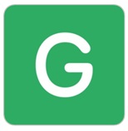
The Grid 3 software has been developed into an iPad compatible application for people using touch, allowing access to a range of resource for communicating with symbols or text.
Key features include:
- Wide range of resources for different ages and abilities
- Research-based approach to symbol and text AAC
- Fast and intuitive in-app editing
- Remote editing from any Windows computer
- Do more with Grid – new resources added every day
- Available in 15 languages
- Text talker to give instant communication for literate users
Compatibility: Requires iOS 11.0 or later. Compatible with iPad.
Prices: Free for 30 days, with the price option being $15.49 per month or $549.99 as a one-off purchase as at 18/10/2019.
More information at:
Grid for iPad SmartBox Web Page
Grid 3 Learning Resources Web Page
You can download this application from the Apple App Store.
Also see below “Grid 3 Software – Paid – Windows”

Snap Core First
The Snap + Core First AAC app is designed for Tobii Dynavox device users and allows you to try the app for free without speech functionality. These additional functions can be purchased at any time.
Compatibility: Requires iOS 10.0 or later
Prices: Free, with in-app purchases
More information at: Tobii Dynavox Web Page
You can download this application from the Apple App Store

Verbally
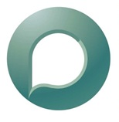
Verbally is an easy-to-use, comprehensive Augmentative and Alternative Communication (AAC) app for the iPad that brings speech to those without and enables real conversations.
Features:
- Core Words Grid - contains 50 essential words to save you over 50% of the taps required to input your sentences.
- Core Phrases Grid - offers common phrases to enable faster & easier conversation.
- Text Prediction
- Choice of 3 keyboard layouts or use a Bluetooth keyboard
- Choice of settings for speaking method.
- A handy chime to get someone’s attention.
- Steady Hands feature – if you have limited fine motor abilities this feature makes it easier to type. With this set to “on”, the app will only register when you lift your finger off of the intended letter on the keyboard.
- No Wi-Fi or 3G connection required.
Compatibility: Requires iOS 8.0 or later
Prices: Free, with in app purchased. Premium cost $159.99 as at 08/11/2019
More information at: Verbally Web Page
You can download this application from the Apple App Store.

GoTalk NOW
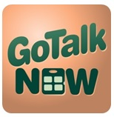
The GoTalk Now is designed for iPad use, allowing for an effective AAC app with adjustable page layouts, customizable navigation, recorded and text-to-speech capabilities, and an included symbol set.
- Use images from your iPad camera, photo library, or the Imagine Symbol set.
- Combine multiple images in a single communication location.
- Move and size text with your fingers so it feels just right.
- Record your voice or use our free text-to-speech voice.
- Add spoken labels (auditory cues) to any button. Great for scanning, guiding visually impaired users, and identifying any new or difficult vocabulary.
- Include a core vocabulary button for extra quick access to important messages.
- Create multimedia social stories and step-by-step instruction layouts by linking pages with an after action.
- Access with single or two-switch scanning.
Compatibility: Requires iOS 9.0 or later
Price: $124.99 as at 08/11/2019.
More information at: Attainment Company Web Page
You can download this application from the Apple App Store.

InnerVoice: Communication
Compatibility: Requires iOS 11.4 or later
Prices: $79.99 as at 04/07/2019
More information at: InnerVoice App Web Page
You can download this application from the Apple App Store.

Android Compatible

JABTalk - Android
Compatibility: Requires Android 4.0.3 and up
Prices: Free
More information at: JabTalk Web Page
You can download this application from the Google Play Store.

LetMeTalk: Free AAC Talker - Android
Compatibility: Requires Android OS 4.0.3 and up
Prices: Free, offers in-app purchases
More information at: LetMeTalk App Web Page
You can download this application from the Google Play Store.

Apple IOS and Android Compatible

Avaz
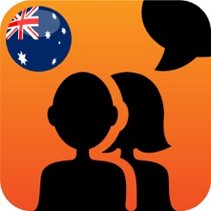
Avaz is a picture and text based communication app for children and adults with communication challenges.
Compatibility: Requires iOS 9.0 or later or Android OS 5.0 and up
Prices: Free
More information at: Avaz App Web Page.
You can download this application from the Apple App Store or the Google Play Store.

TouchVoice Gold
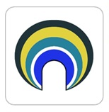
The app transforms a mobile tablet/phone into an Augmentative and Alternative Communication (AAC) device for those who are unable to produce understandable natural speech on their own.
Compatibility: Requires iOS 9.2 or later or Android OS 4.3 and up.
Prices: $30.99 as at the 04/07/2019 at the Apple Store, and $30.99 as at the 04/07/2019 at the Google Play store.
You can download this application from the Apple App Store and the Google Play Store.

TippyTalk
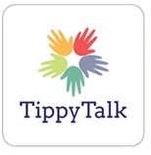
The TippyTalk app allows a person living with a verbal disability to communicate by translating pictures into text messages which are then sent to a family member or care givers phone or tablet. The app is set up so that a picture of an object, place or person that is identifiable and familiar to the person living with the disability is applied to an appropriate text, allowing communication through images.
Compatibility: Requires iOS 8.0 or later or Android 4.4 and up
Prices: Free to download with one-month free trial. A subscription can be bought for $65.99 per quarter or $154.99 per year.
More information at: TippyTalk Web Page
You can download this application from the Apple App Store and the Google Play Store.

Predictable AAC – Paid
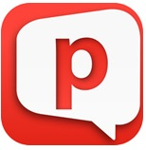
The Predictable app combines AAC and text-to-speech technology to allow non-verbal individuals to communicate. It features full customisation of layout and voice options, can be used across apps, and allows for switch access.
Compatibility: Requires iOS 10.0 or later or Android OS 4.2 and up
Prices: $249.99 as at the 04/07/2019 at the Apple Store, and $264.99 as at the 04/07/2019 at the Google Play store.

More information at: Predictable App Therapy Box Web Page.
You can download this application from the Apple App Store and the Google Play Store.

ClaroCom
Compatibility: Requires iOS 9.0 or later or Android OS 4.1 and up
Prices: Free
More information at: ClaroCom App Claro Software Web Page
You can download this application from the Apple App Store and the Google Play Store.

Vocalyx
Compatibility: Requires iOS 9.0 or later or Android OS 4.4 and up
Prices: Free, offers in-app purchases
More information at: Vocalyx Web Page
You can download this application from the Apple App Store and the Google Play Store.

2Talk-AAC
Compatibility: Requires iOS 8.0 or later or Android OS 4.0.3 and up
Prices: Free to download and $17.99 for the Full version at the Apple App Store, and $5.99 at the Google Play Store, as at the 04/07/2019.
You can download this application from the Apple App Store and the Google Play Store.

Voice4u AAC
Compatibility: Requires iOS 8.0 or later or Android OS 4.4 and up
Prices: $89.99 as at the 04/07/2019 at the Apple Store, and $59.99 as at the 04/07/2019 at the Google Play store.
More information at: Voice4u Web Page
You can download this application from the Apple App Store and the Google Play Store.

Windows Compatible

Grid 3 Software – Paid - Windows
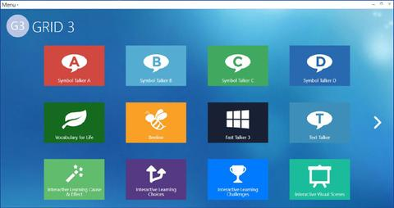
Grid 3 is a complete communication solution that enables people to have a voice, control their environment and live more independent lives. It is designed for anyone with complex communication or access needs. It features grid sets for talking with symbols or text, and content for all ages and abilities, which can be edited and adapted to suit individual communication needs.
The Original software can be downloaded onto any Windows PC or tablet, allowing for full control of your device, communication, and environment using touch, switch, eye gaze and pointing devices.
Key Features include:
- Option to use given Grid Sets or edit to customise and create your own sets.
- New streamlined edit menus make editing intuitive, quick and simple.
- Use to generate messages using symbols, core words or text-to-speech
- Control using touchscreen, switch/scanning, head-tracking and eye-gaze, and more.
- Control your environment from the Grid 3, for example change TV channels.
- Operate a mobile phone from Grid 3 using your preferred access.
- Compatible with social media and communication apps.
- Expand the early leaning using the Interactive Learning Grids.
Compatibility: The Grid 3 Software is available for download on any Windows PC or tablet, and is commonly used by more formal speech generating and communication devices.
Prices: Free for 60 days, with prices after that varying from $1012 to $1480 depending on add-ons selected and provider requirements.
More information at:
Grid 3 Smartbox Web Page
Grid 3 Learning Resources Web Page

