Speed Dial Apps
Speed dial apps usually group your main contacts in one place, allowing you to find them quickly in order to make a call, without having to scroll through the entire list of contacts in your phone.

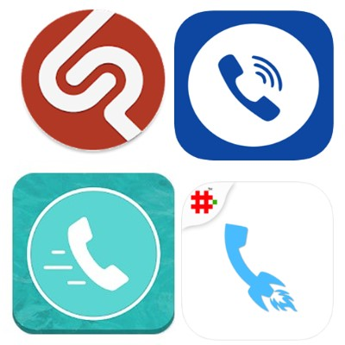

Access Needs:
- Physical
- Cognitive

Applications:

Speed Dial Widget for Android
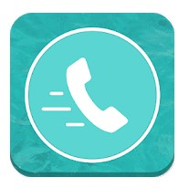
Speed dial widget is the best way to get in touch with your favourites with just one touch. You can Message, Call and Video call etc. Straight from your home screen.
Compatibility: Android 4.1 and up.

Features:
- Just one tap and do Actions: Phone Call , SMS , WhatsApp message, WhatsApp Call , Skype call, Facebook messenger, Google Duo Video call.
- Choose what to do on single or double tap on contact like Call or Message etc. Or you can choose specific action for each contact.
- You call and message to all your selected contacts from home screen using app widget.
- Categories your contacts into groups like Family, Business, Friends etc
- You can add each group widget into home screen
- Change shape of Contact List photos.
- Choose app colour theme or your choice.
- Dual SIM Support
- Dial pad
- Backup and Restore app data
Price: Free to install, in app purchases for more features.
You can get this app from the Google Play Store

Speed Dial for Android
Get quick and easy access to your contacts with one touch.
Compatibility: Android 4.1 and up.
Features:
- Selected contacts will be displayed as a circle, with their contact image. If your contact does not have an image, you can add an image or have it displayed as an empty contact
- One touch select to call or write a SMS
- Create an unlimited number of groups for your contacts, such as Friends and Family. The contact groups are arranged according to your manual order
- Add each group as a widget on your home screen for quick access
- Add customise contact effects
- Customise display settings, including text size and colour
- Import files and contacts from Google Drive
- Dual SIM Support
- Back up and restore data
Price: Free to install, in app purchases for more features.
You can get this app from the Google Play Store

Speed Dial Free for Android
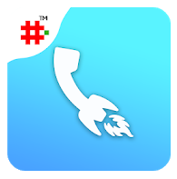
Speed Dial Free is an excellent app for easy and rapid call, email and message to your speed dial contacts. This way you can quickly communicate with your frequently used contacts. It can also be used in emergency situations for quick call and SMS.
Compatibility: Android 4.4 and up.
Features:
- You tap to call the contact and long press for SMS, however you can change this in the setting options
- You can customise your settings to include WhatsApp message and FaceTime (Audio and Video)
- Create a maximum of 10 groups with unlimited number of contacts. This allows you to send a group message or email in a very fast way using the inbuilt templates
- You can call all your selected contacts from the home screen using app widget, without having to open the Speed dial app. You can add unlimited contacts to the widget
- Long Press on Speed Dial Free logo on Speed dial home page for voice command dial, speak name to instantly call
- You can set up multiple call reminders for speed dial contacts, with customised notes
Price: Free to install, in app purchases for more features.
You can get this app from the Google Play Store

Favourites Widget Pro for Apple

Call and text your favourite contacts directly from the Widgets screen, without having to open other apps. Swipe right from the lock screen, home screen, or alternatively pull down the widgets screen from within any app and get immediate access to your favourite contacts. This Widget will support you to call and message. You can use the following apps; WhatsApp, Slack, Telegram, Facebook Messenger, email and FaceTime.
Compatibility: iOS 8 and up.
Features include:
- Unlimited contacts and groups
- You can organise contacts into groups, such as ‘Family’ and ‘Friends’
- 3D Touch in the widget for quick call
- Order Uber of Lyft to your favourite places from the widget
Price: Free to install, in app purchases for more features.
You can get this app from Apple App Store

Free Speed Dial for Apple
Get in touch with your favourite contacts with just a single touch. You can use the app to call, as well as to iMessage, SMS, FaceTime (Audio and Video), WhatsApp and email.
Compatibility: iOS 7.0 and up.
Features:
- Add as many contacts as you want, with multiple pages
- Contact photos will automatically sync from your contact details
- Change display settings for your preference
- The picture and colour can be changed for each contact
Price: Free to install, in app purchases for more features.
You can get this app from Apple App Store

Speed Dial Lite for Apple
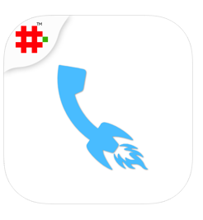
Speed Dial Free is an excellent app for easy and rapid call, email and message to your speed dial contacts. This way you can quickly communicate with your frequently used contacts. It can also be used in emergency situations for quick call and SMS.
Compatibility: iOS 10.3 and up.
Features:
- You tap to call the contact and long press for SMS/iMessage, however you can change this in the setting options
- You can customise your settings to include WhatsApp message and FaceTime (Audio and Video)
- Create a maximum of 10 groups with unlimited number of contacts. This allows you to send a group message or email in a very fast way using the inbuilt templates
- You can call all your selected contacts from the home screen using app widget, without having to open the Speed dial app. You can add unlimited contacts to the widget
- Long Press on Speed Dial Free logo on Speed dial home page for voice command dial, speak name to instantly call
- Add up to 4 contacts to 3D touch mode and you will be able to access them even faster
Price: Free to install, in app purchases for more features.
You can get this app from the Apple App Store

