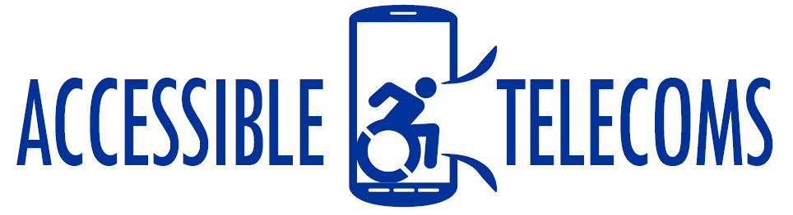

Hearing Aid Apps
These hearing aid apps learn your hearing profile and adapt sounds so the user can hear better. They are best suited for people with minor hearing impairments that don’t need to wear a hearing aid.
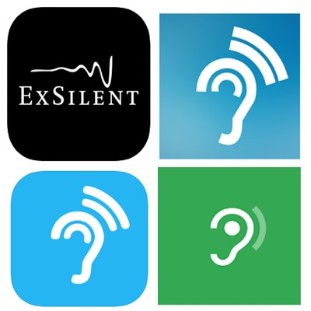

Access Needs:
- Hearing

Applications:

Petralex Hearing Aid for Apple
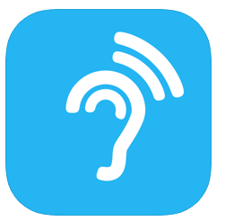
Petralex Hearing Aid will automatically adjust to specific features of your hearing. You only need a simple headset in order to use this hearing app.
Compatibility: iOS 10.0 and up.

Features:
  - Automatic adjustment to hearing specifics
  - Hearing correction for each ear
  - Adaptation to different types of environment
  - Amplify up to 30 dB with a wired headset
  - Built-in hearing test
  - Dynamic compression. Amplify quiet sounds without losing the overall volume
  - Using 4 options of sound amplifier
  - Using the built-in 4-week adaptive course for getting used to the hearing aid app
  - You can use your smartphone as a remote mic
  - Support of Bluetooth headsets and Air Pods
  - Use the headset button to control the app
Price: Free to install, in app purchases for more features.
You can get this app from the Apple App Store

HearYouNow for Apple
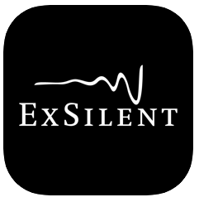
The HearYouNow app is your personal sound amplifier. Adjust it to your personal needs! You will understand conversations better in high volume situations such as restaurants and watching television. It is perfect for you if you have impaired hearing but are not ready for a hearing aid.
Compatibility: iOS 4.3 and up.
Features:
- Volume is adjustable per ear
- Individual frequency sliders allow volume control for 3 frequency bands. This should help you better understand what you are hearing.
- ‘Focus near/far’ feature allows you to choose to focus on conversations close by or conversations that occurring far away
- A simple button push will allow you to replay the last 20 seconds of the conversation, in case you have missed any part of it
Price: Free to install, in app purchases for more features.
You can get this app from the Apple App Store

Hearing Aid for Android
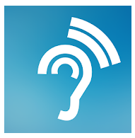
The Hearing Aid App coupled with a standard handset can provide a substitute to your traditional hearing aid. You will need to complete a professional built in hearing test. The App will automatically auto-tune to your hearing specifics.
Compatibility: Android 5.0 and up.
Features:
- The hearing test is only 3 minutes
- Choose the best sound amplification mode for you
- You can control noise level
- Supports auto-adjustment of volume balance between the left and the right ear
- You can export text results from the Petralex Hearing App onto the app
Price: Free to install, in app purchases for more features.
You can get this app from the Google Play Store

Sound Amplifier for Android
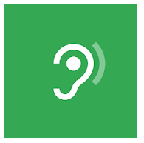
The Sound Amplifier App enhances audio from your Android device using a headset. It will assist you to carry on conversations in loud environments by making audio clear and easier to hear. You should hopefully have a more comfortable and natural listening experience.
Compatibility: Android 6.0 and up.
Features:
- Boost quiet and reduce loud sounds around you and on your device.
- Personalise your listening experience by adjusting audio or microphone settings with the simple tuning
- You can quickly customise the sound enhancement to reduce background noise
Price: Free to install
You can get this app from the Google Play Store

