Speak and Read Calls
Speak and read calls are ideal if you can speak on the phone but not hear, and don't use a computer or mobile phone.
You speak directly to the other person (no typing) and read the responses (you can’t hear the responses).
Use a TTY (telephone typewriter)

How it works
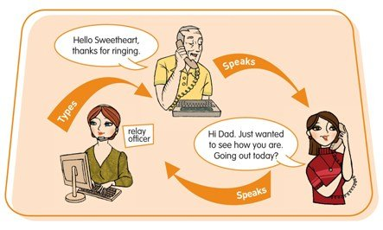
This type of relay call is useful if you prefer to use your own voice. You speak directly to the other person— you don't need to type. You then read their responses, typed by the relay officer, on your TTY.
Relay officers are the central link in the phone call. They stay on the line through out each call to help it go smoothly, but do not change or interfere with what each person says.

Equipment
You will need a specialised fixed-line phone known as a TTY.
A TTY has a small display screen where you can read what the other person has said to you. (TTYs also have a keyboard to allow users to type their side of the conversation if they want to.)
The main model of TTY for Speak and Read calls is the Uniphone, a combined TTY and telephone.
In most cases you can rent a TTY for about the same cost as an ordinary phone through the disability equipment schemes offered by Telstra and Optus.

Other equipment
You might find other equipment useful, such as a phone arm, flashing light or phone double adaptor. This will depend on your personal requirements.
Contact the NRS Helpdesk for more information on disability equipment schemes, and where to obtain TTYs and other specialised equipment that you might need. You can also look for TTYs in our device database.

What does it cost?
Relay calls within Australia are free. However you will be connecting to the internet and charges for your data use will depend on your internet or mobile data plan.
If you want to make calls to phone numbers overseas or premium rate (1900) calls you will need a prepaid phone card or an NRS account.

Further information and useful links:
Teletypewriter (TTY) Options Fact Sheet
Making a Speak and Read Call - Auslan Video (YouTube)
Answering a Speak and Read Call Instruction Sheet
NRS Service Features Web Page
Numbers for calling an NRS User

*The information contained in this document comes from the National Relay Service Australia.

